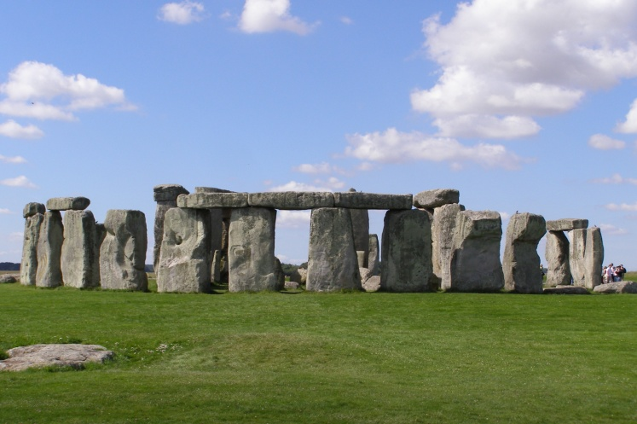

**Year 3 Summer Term**

**Tribal tales- How did we get from stone to steel?**

**Computing**

* **Machines and Mechanisms- Lego WE DO**
* **Real life algorithms**
* **Internet safety**

**PSHE**

* **Recognising and responding to bullying.**
* **Develop self respect and empathy for others.**
* **Being a part of the community.**

**RE**

* **Christianity – Creation Story and Parables**
* **Hinduism**

**Music**

* **Charanga Summer Term Unit**

**Art/DT**

* **Drawing and Printing – Cave Paintings**
* **Construction – join, repair and strengthen**

**PE**

* **Athletics**
* **Cricket**
* **Sports day**

**History/Geography**

* **The Stone Age, Bronze Age and Iron Age**
* **Settlements**
* **Locations - Stone Henge, Skara Brae, Iron Age Forts**

**Science**

* **Plants – conditions for growing, pollination, seed formation and seed dispersal, water transportation**
* **Plant hunters, Marie Curie, George Washington Carver, William Smith**

**Maths**

* **Fractions**
* **Measurement – Time and money**
* **Properties of Shape**
* **Measurement – Mass and Capacity**
* **Consolidation of the four operations**

**Reading books**

* **Stone Age Boy**
* **I was born in the Stone age**
* **How to Wash a Woolly Mammoth**
* **Voices in the Park**

**English/writing opportunities**

* **Biography**
* **Setting/Character description**
* **Recount**
* **Diary Entry**
* **Poetry**
* **Instructions**
* **Explanations – Plants**