

Special Educational Needs and / or Disabilities Report.

**Introduction**

At Collingwood, the achievement, attitude and well-being of every child matters. Children join our setting with a variety of needs and each child has a right to have their needs recognised and met to suit them individually. Inclusion is the responsibility of every member of staff within our school. By taking account of individuals needs and differentiating our resources and practice, we provide an inclusive curriculum to ensure the best possible progress for all of our pupils, whatever their disabilities. We respect the unique contribution which every individual can make to our school community and we strive to ensure a culture of belonging exists for all.

The school recognises that children with special educational needs may fall into one or more of the following categories:

* Communication and interaction
* Cognition and learning
* Social, emotional and mental health
* Physical and sensory.

Enquiries about an individual child’s progress should be first addressed to the child’s class teacher, since he or she knows the child best. Appointments can also be made to speak to the SENDCO, Mrs Patterson.

We are mindful of the importance of parental involvement in the support of our pupils and seek fully to involve parents and carers in the SEND process and provision. All of the children on the SEND register are integrated fully into mainstream classes and supported as appropriate by all staff members

Mrs Patterson is our fully qualified / trained Special Educational Needs Coordinator who provides advice and guidance to staff. She completed the National Award for SEND Coordination (NASENDCO) at Sunderland University and graduated in November 2020.

**Whole School Vision**

We’re here to learn and never give up,

Respect and Friendship bring us luck,

Think big, look far and make the best of who you are!

Our Local Offer lets you understand how we support pupils with special educational needs and disabilities. We consult with pupils and their families on our local offer by:

- Having regular meetings with children and their families.

- Day to day discussions on anything new that has arisen.

- Introducing them to outside agencies they may be able to provide support.

- Letting them know what is available for them and their children within the Local Authority and Community.

**Supporting Pupils with Special Educational Needs / Disabilities and Their Families**

The SENCO and class teachers will co-ordinate Special Needs identification, assessment and support. The SENCO will liaise closely with the class teachers and support staff, as well as external agencies. In addition to day-to-day liaison, parents will be informed if there are any concerns regarding their child within school. From that, following the graduated response any child that may require further input, parents/carers will be encouraged to discuss any further concerns where the SENCO may suggest additional outside agency involvement to support the child further.

Children with special educational needs will often be supported in the classroom situation. The SENCO and class teachers will devise learning strategies through quality first teaching to accommodate children of all needs and abilities and will liaise regularly. When individual children present behaviour untypical of their peers, the class teacher will request the SENCO comes to observe the child. Following this, the SENCO will discuss matters with parents/carers and agree appropriate action plans. Where no improvement occurs, following a sustained period of intervention, or when the class teacher or SENCO have additional concerns, the help, support and advice of external agencies will be sought.

Collingwood Primary School will endeavour to use its resources to provide appropriate support to children with special educational needs, thus enabling all children to obtain maximum benefit from the full school curriculum.

Children are likely to fall into the following categories:

- Those with learning difficulties.

- Those with visual or auditory impairment.

- Those with a physical disability.

- Those with social, emotional or mental health difficulties

**We will let families know about any concerns about a pupil’s learning by:**

- Daily chats with teachers before and after school

- Meetings with the SENCO

- Discussions over the phone

- Formal meetings involving other agencies

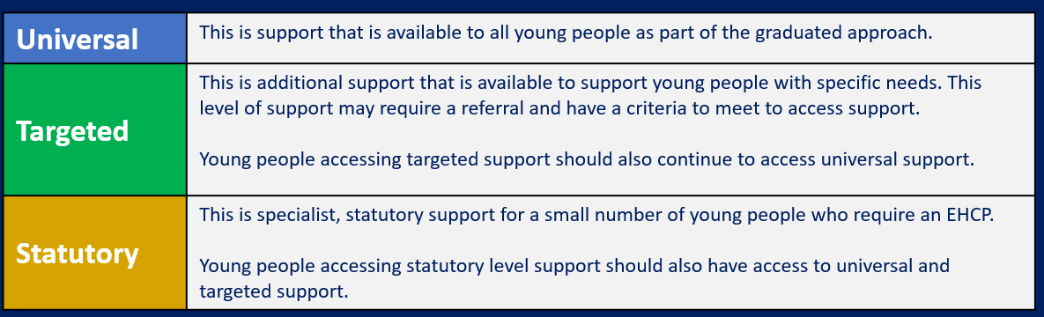

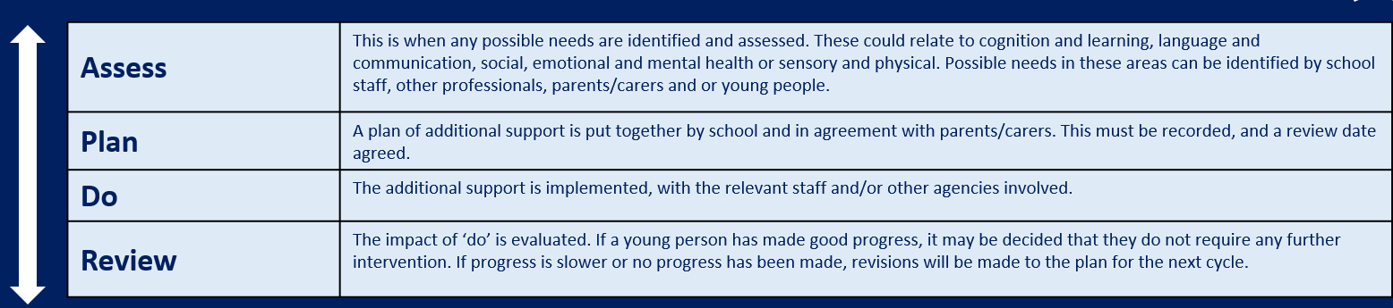

**When a pupil is identified as having special educational needs, we support their development and progress by:**

* Developing an Individual SEND Support Plan containing SMART targets.
* Developing small group support in class from class teacher/Teaching assistant.
* Give 1:1 support where necessary for children with SEND.
* Develop Small group/1:1 support as appropriate.
* Ensure access to learning through the appropriate differentiation of tasks and activities.
* Provide specialist equipment or modified resources where necessary.
* Use visual support and hands on resources where necessary.
* Implement specifically tailored support strategies and programmes, e.g. devised by the educational psychologist, Language and Communication Team, Occupational Therapist or Dyslexia team.

**External agencies**

A wide variety of agencies are available to support children with SEN and if the child has an EHC plan, the agencies involved (health care and social care) are required by legislation to work jointly in forming and carrying out that plan. The school liaises closely with a wide range of other colleagues and works with them as they provide therapy within the school. The school refers and liaises regularly with the following services:

∙ The School Nurse.

∙ The Educational Psychologist.

∙ The Speech and Language Team.

∙ Occupational therapy service.

∙ Visually and hearing impaired support service.

∙ Behaviour outreach service (Silverdale).

∙ Dyslexia Team

∙ The Language and Communication Team

∙ LA SEND team

∙ CAMHS

∙ HIVE

∙ Collingwood Family Support worker (Mrs Cunningham)

Support staff is placed where they are needed throughout the school to ensure pupil progress, independence and value for money

**Transition**

We will work in partnership with other education providers to ensure that pupils make a successful transition to the next stages of their learning, through careful and coordinated planning of the transition. We provide the following support to pupils when they are leaving the school:

- Extra transition days for specific pupils.

- Visits of new setting/school for parents and children.

- Parent / child meeting with new and existing staff.

- Transition intervention provided by Local Authority for specific pupils.

- Parent and SENCO meeting involving any outside agencies that needs to be involved.

- New staff visit child in their existing setting.

**Staff Training**

All staff have completed, and will continue to receive, ongoing training in special educational needs and disabilities. Staff training includes:

* Whole School Autism Spectrum Condition (ASC) training delivered by School Educational Psychologist.
* Whole School ADHD training delivered by School Educational Psychologist.
* Read Write Inc Training
* PACE training delivered by HIVE
* Trauma Informed Training / ACE
* An honest view of Autism / Sensory Processing from Richie at Awesometistic
* SENDCO staff meeting regarding SMART targets and SEND plans.
* Sensory Processing training to support the implementation of the new Sensory Room.

**Supporting Families**

The school works in partnership with families to help them support their children’s learning outside of school.

Mrs Cunningham our family support worker is also able to signpost appropriate services / organisations through the Local Offer to families

[Local Offer: Special Educational Needs and Disabilities (SEND) | North Tyneside Council](https://my.northtyneside.gov.uk/category/1243/local-offer-special-educational-needs-and-disabilities-send)

**Further Information**

Behaviour and anti-bullying policies are regularly reviewed with a focus on how they affect pupils with special educational needs and/or disabilities. Other useful documents such as our Special Educational Needs and Inclusion Policy are also available on the school website.

The school’s self-evaluation process will look at teaching and learning for pupils with special educational needs and disabilities. All school-related activities are evaluated in terms of their benefit to the learning and inclusion of pupils with special educational needs and disabilities.

If you would like further information about what we offer here at Collingwood Primary School then please contact Mrs Patterson (SENCO) on 0191 605 3378.

**School entitlement offer to pupils with special educational needs or disabilities**

|  |  |
| --- | --- |
| **Area of Need** | **Support Available Within School** |
| **Communication and Interaction Needs:**  e.g.  ∙ Autistic Spectrum Condition  ∙ Speech, Language and Communication Needs  ∙ Social communication difficulties | ∙ Visual timetables  ∙ Areas of low distraction –individual tables and quiet areas of the classroom.  ∙ Privacy screens  ∙ Support / supervision at unstructured times of the day.   ∙ Social stories  ∙ Nurture time  ∙ Small group work  ∙ ICT is used to support learning where appropriate (Ipads / chrome books for widget)  ∙ Widget – an online tool to create visual aids  ∙ Individual programmes to support speech and language development.   ∙ Strategies to reduce anxiety / promote emotional wellbeing.  ∙ Where appropriate we will use support and advice from other agencies to meet the needs of pupils.   ∙ Planning, assessment and review SEND plans, twice a year.  ∙ Work with pupils, parents, carers and staff to develop and review plans based on the need of the pupil.  ∙ Teaching resources are routinely evaluated to ensure they are accessible to all pupils.   ∙ Differentiated curriculum and resources  ∙ Small fidget toys  ∙ Oasis room and Zen Den |
| **Cognition and Learning Needs:**  e.g.  ∙ Moderate Learning Difficulties | ∙Strategies to promote/develop literacy and numeracy.  ∙ Provision to support access to the curriculum and to develop independent learning.  ∙ Small group targeted intervention programmes are delivered to pupils to improve skills in a variety of areas, i.e. BR@P, RWI, Dyslexia, Fresh Start and Reading Plus  ∙ ICT is used to reduce barriers to learning where possible (Widget).  ∙Visual overlays, specific pencils and pencil grips, writing slopes and coloured books to support individual children.  ∙ Support and advice is sought from outside agencies to ensure any barriers to success are fully identified and responded to.   ∙ Planning, assessment and review SEND plans, twice a year.   ∙ Access to teaching and learning for pupils with special educational needs is monitored through termly SEND walks and observation by SENDCO.  ∙Teaching resources are routinely evaluated to ensure they are accessible to all pupils.  ∙ Work with pupils, parents, carers and staff to develop and review plans based on the need of the pupil.   ∙ Differentiated curriculum and resources |
| **Social, Mental and Emotional Health**  e.g.  ∙ Behavioural needs  ∙ Social need  ∙ Mental health needs  ∙ Emotional Health and Wellbeing | ∙ The school vision values all pupils.  ∙ Behaviour management policy and strategies to support pupils e.g. ∙ Behavioural needs ∙ Social need ∙ Mental health needs ∙ Emotional Health and Wellbeing to make positive decisions about behavioural choices.  ∙ The schools behaviour policy identifies where reasonable changes can be made to minimise the need for exclusions.  ∙ The school provides effective nurture all pupils.  ∙ Support and advice is sought from outside agencies to support pupils, where appropriate e.g. Silverdale and Educational Psychologist  ∙ Small interventions and nurture groups are used to improve social skills and help them deal more effectively with stressful situations.  ∙ Promoting outdoor learning to offer a different approach to the curriculum.  ∙ Information and support is available within school for behavioural, emotional and social needs.   ∙ Social stories: Back to school, playtime, lunchtime, routines, kind hands, going to the toilet, when I feel angry  ∙ Oasis room and Zen Den |
| **Sensory and Physical Needs:**  e.g.  ∙ Hearing/Visual Impairment  ∙ Multi-sensory impairment  ∙ Physical and Medical Needs | ∙ Support and advice is sought from outside agencies to support pupils, where appropriate (Sensory support team)  ∙ ICT is used to increase access to the curriculum e.g. Widget   ∙ Support to access the curriculum to develop independent learning (differentiation).  ∙ Advice and guidance is sought and acted upon to meet the needs of pupils who have significant medical needs (disabled toilet).   ∙ Access to programmes to support Occupational Therapy / Physiotherapy.  ∙ Support with personal care if and when needed.  ∙ Staff receive training to ensure they understand the impact of a sensory need upon teaching and learning.  ∙ Staff understand and apply the medicine administration policy.   ∙ The Special Educational Needs Coordinator completes regular training in order to offer advice and guidance to staff about the needs of pupils. |