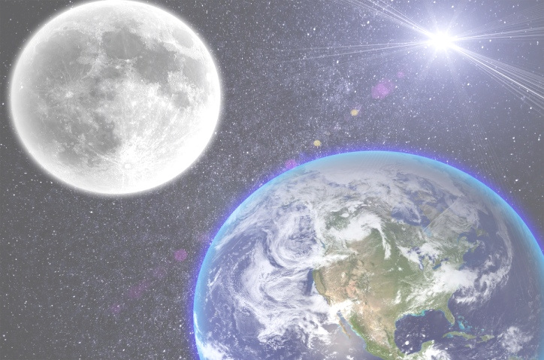

**Year 1 Spring**

What is spectacular about space?

**Art/DT**

Design and make a healthy breakfast for an astronaut

Wenzel Hablik- painting planets in multimedia

Watercolour planets