

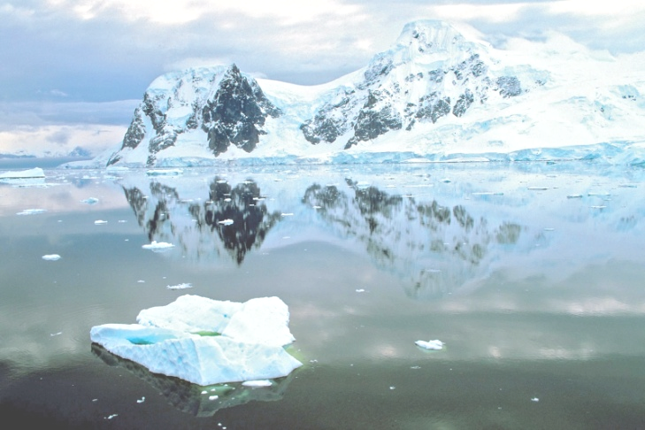

**Science**

**-Animals including humans-** investigating habitats and microhabitats and looking at what factors make the habitat suitable for what lives there.

- Notice that animals, including humans have offspring and grow into adults.

-Describe the importance of exercise and eating the right amount of healthy food.

-Key scientist: **David Attenborough**

**Career opportunities: nurse, vet**

**Career opportunities: Nurse, vet**

**Year 2 Spring**

Frozen World

**RE**

-Judaism and Christianity – prayer and celebrations

-Shabbat, Yom Kippur, Hannukah

-The teachings of Jesus, the Easter story

**Music**

Charanga Spring Year 2 unit.