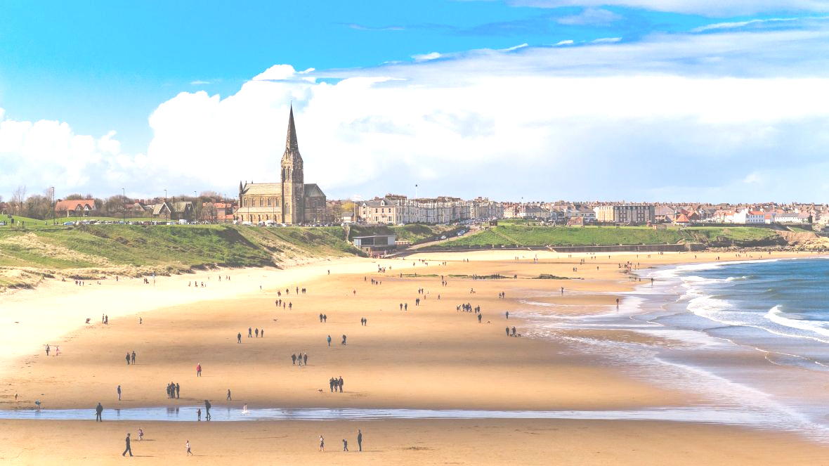

Year 1 Summer

Beside the seaside

**History/Geography**

To compare and contrast seaside holidays in the past.

To explore and observe old objects and photographs from the past.

To explore key physical features of our local area and contrast this with global features in different areas of the world.

How to stay safe around water

**English/writing opportunities**

Descriptive writing

Drama opportunities throughout

Use of speech and punctuation

Poetry

Create a recount of a trip

**Science**

To identify and name a variety of common plants and trees.

Identify and describe the basic structure of plants and trees.

Observe and describe how bulbs grow into mature plants.

Find out and describe how plants need water, light and temperature to grow.

**Art/DT**

Tie dye T-shirts with a symbol stitched on using a running stitch.

Playdough making using scales and measuring cups.

Colour wash printing seascapes inspired by Henry Matisse

To use 2Simple to explore lines and colour