

**SEND & Inclusion Policy**



Written by: Melissa Patterson, September 2024

Role: SENDCO

Approved by: Rachel Weddle (SEND Governor)

Date to be reviewed: September 2025

**Welcome to our SEND Policy.**

This policy forms part of the North Tyneside Council Local Offer for SEND. The Local Offer is an authority’s publication of all the provision they expect to be available across education, health and social care for children and young people in their area who have SEND.

More information on the local offer can be found at:

[Local Offer: Special Educational Needs and Disabilities (SEND) | North Tyneside Council](https://my.northtyneside.gov.uk/category/1243/local-offer-special-educational-needs-and-disabilities-send)

We have a legal duty to publish information about how our school’s policy for SEND is implemented and this can be found in our separate SEND Information Report.

**Introduction**

At Collingwood, Children join our setting with a variety of needs and each child has a right to have their needs recognised and met to suit them individually. Inclusion is the responsibility of every member of staff within our school. By taking account of individuals needs and differentiating our resources and practice, we provide an inclusive curriculum to ensure the best possible progress for all of our pupils, whatever their disabilities. We respect the unique contribution which every individual can make to our school community and we strive to ensure a culture of belonging exists for all.

**Our Vision**

Our SEND Policy supports our whole school vision of *‘making the best of who you are’.*

We work in the best interests of every child and we are committed to a policy of inclusion.

Our aims for SEND are:

* All children with Special Educational Needs and Disabilities (SEND) will be able to access a broad and balanced curriculum
* Our work will always be child-centred with the views of the child considered in light of their age and understanding
* Every effort will be made to include parents & carers in the education of their children through regular contact and engagement

**Policy Development**

This policy is written in line with the requirements of:

* The Children & Families Act 2014
* The Equality Act 2010
* The SEN Code of Practice 2014

**Policy Consultation & Review**

This policy is reviewed annually by the full governing body. We inform all new parents and carers about this policy and it is always available on our website. A hard copy can be obtained at the school office.

We would welcome your feedback and future involvement in the review process.

The best person to contact would be Mrs Patterson via the school office email or school telephone number below:

[Collingwood.schooloffice@collingwoodprimary.org.uk](mailto:Collingwood.schooloffice@collingwoodprimary.org.uk)

0191 605 3378

**Definition of SEN**

A child or young person has a special educational need (SEN) if they: ‘have a learning difficulty or disability which calls for special educational provision to be made for them’ (SEN Code of Practice p15)

A child of compulsory school age or a young person has a learning difficulty or disability if they:

* Have a significantly greater difficulty in learning than the majority of others of the same age.

or

* Have a disability that prevents or hinders them from making use of facilities of a kind generally provided for others of the same age in mainstream schools or mainstream post-16 institutions.

**Definition of Disability**

Many children and young people who have SEN may have a disability under the Equality Act 2010 - that is ‘...a physical or mental impairment which has a long-term and substantial adverse effect to carry out normal day-to-day activities.

’ This definition provides a relatively low threshold and includes more children than many realise. ‘Long term’ is defined as a ‘year or more’ and ‘substantial’ is defined as ‘more than minor or trivial.’

**The Role of the SENDCO**

All mainstream schools and academies in England must ensure that here is a qualified teacher designated as SENDCO for the school. This person must also achieve a National Award in Special Educational Needs Co-ordination within three years of taking on the role.

The role of the SENDCO is to:

* Alongside the headteacher & governing body, ensure the strategic development of SEN policy & provision
* Oversee the day-to-day operation of the schools SEN Policy
* Co-ordinate provision for children with SEN
* Provide professional guidance to colleagues
* Liaise and work closely with children, parents & outside agencies
* Maintain up to date records for children with SEN

SENDCO: Melissa Patterson

Contact:

**Every teacher is a teacher of SEND**

Your child’s teacher is the key person at school with the responsibility for the education of your child and they should be your first port of call if you have any concerns regarding their learning. At the heart of The Teachers Standards (2012) is the requirement for all teachers to ‘adapt teaching to respond to the strengths and needs of all pupils.’

**The Role of the Governing Body**

At Collingwood Primary School, we are committed to working with all members of our community and that includes our Governing Body. This policy has been reviewed and agreed with the governing body and our current SEN Governor is Rachel Weddle.

**Identification of SEN**

In accordance with the SEND Code of Practice there are four broad areas of need and support.

These are:

* Cognition & Learning
* Communication & Interaction
* Social, Emotional & Mental Health
* Sensory and/or Physical Disability

When assessing a child and identifying if they have an additional need they will be assessed using the four areas and, after close consultation with parents, may be put on the schools SEND Register under one of the above categories if a need is identified.

**Quality First Teaching**

All children and young people should expect to receive good quality and differentiated teaching. This is the first step in responding to children and young people who may have SEN. Our staff partake in continued professional development (CPD) & our SENCO runs specific SEN CPD sessions every term.

**The Graduated Approach to SEND**

Where a pupil is identified as having SEND, to enable the child to participate, learn and make progress, schools should act to:

* Remove barriers to learning
* Put effective special educational provision in place

The graduated approach is North Tyneside’s approach to supporting children and young people who may have additional needs.

There are three levels of support depending on the child or young person's needs.

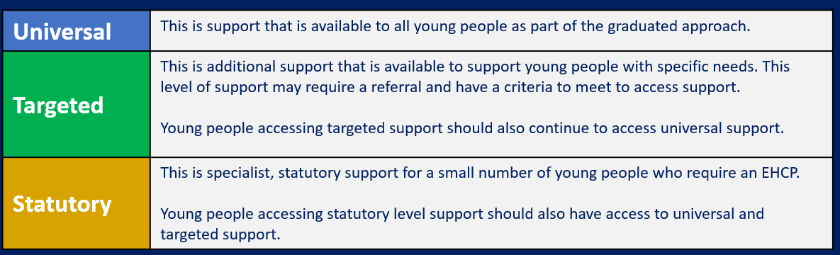

**SEND support Plan**

At Collingwood, we use an Assess, Plan, Do, Review (APDR) model to assess needs and implement appropriate support.

* Assess - What are the child’s successes? What are their challenges?
* Plan - What can be put in place?
* Do - Take action.
* 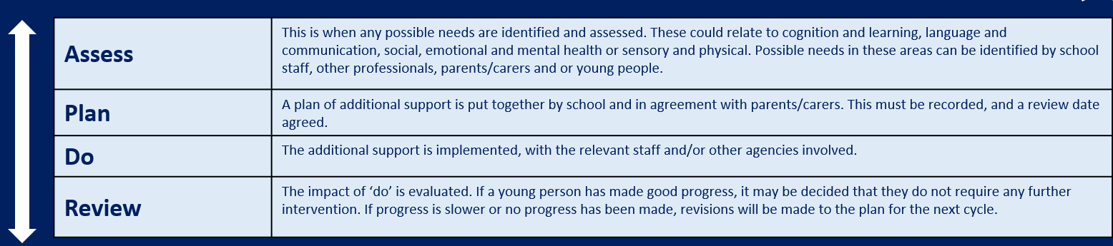Review - Does it work?

The APDR implementation begins at a whole school level. Teachers are continuously assessing, planning, implementing and reviewing the approach to teaching all children, in line with the Code of Practice.

Where a child has been identified as needing SEND Support this process becomes increasingly personalised.

* Individual assessment leads to a growing understanding of the barriers and gaps in learning.
* Continual reflection on approaches to meeting the child’s needs lead to a growing understanding of strategies that enable the child to make progress

At Collingwood, a SEND Support Plan is implemented to help to support a child and detail their strengths and interests as well as supportive measures put into place to help them to achieve their goals. The SEND Support Plan follows a process of Assess, Plan, Do and Review and should be reviewed regularly (at least termly) to ensure that the support provided remains appropriate.

**Pupil Passports**

All pupils at Collingwood Primary School, who are receiving SEN Support or have an EHCP, will have their own Pupil Passport. These are created through conversations between children and members of staff and they ensure that the children’s views and opinions, on how they learn best, are heard and recognised. These focus on a child’s strengths, their individual targets and will detail the strategies used and the special educational provision the child is receiving.

**Education Health & Care Plans**

An Education, Health and Care Plan (EHCP) looks at all of the needs that a child or young person has that are identified as a barrier to their learning. The child or young person, their parents/carers and professionals decide on the outcomes that they would like to achieve and when by. The plan then identifies what support must be put into place to support the achievement of these outcomes.

Not all children who have SEND need an Education, Health & Care (EHC) plan to have their needs met. Most children with SEND have their needs met with SEND Support. An EHC plan is for pupils who have complex special educational needs & disabilities that cannot be met through SEN Support. Children with EHC plans have Pupil Passports and their EHC plan will also be formally reviewed annually.

More information regarding an EHC plan can be found here:

[Finding your way around the support system | North Tyneside Council](https://my.northtyneside.gov.uk/category/1245/finding-your-way-around-support-system)

**Partnership with Parents**

We know that effective partnerships between school and home help to secure better outcomes for children. In line with the Code of Practice, parents will be active participants in planning and reviewing the provision that is in place for their child. Parents of children with SEND are regularly informed of their child’s learning via face to face meetings with class teachers and the SENDCO.

During these meetings, parents will be able to gain information on:

* Their child’s pupil passport.
* Their child’s personalised targets on their APDR plan (both long term and short term).
* Interventions their child is receiving.

Parents and carers will be treated as partners and encouraged to:

* Recognise and fulfil their responsibilities as parents and play an active and valued role in their children’s education
* Have knowledge of their child’s entitlement within the SEND Framework
* Make their views known about how their child is educated
* Have access to information, advice and support about their child’s special educational provision.

**Pupil Involvement**

Pupils are involved in the target setting and development of their SEND plans as relevant and appropriate to age and ability. On every pupils ADPR plan, there is an option for children to have their say and add pupil voice.

Annual Educational Reviews are held for children who have Education Health and Care plans. Children contribute to these by joining the meeting for an appropriate length of time (usually with support) or by working with a well-known adult who seeks their views prior to the meeting, with visual prompts.

On a termly basis pupil views are sought through a visual questionnaire and a conversation with the SENDCO during a ‘SEND walk’ or ‘Sensory Audit’. This is reported to the head teacher and often fed back to class teachers where appropriate.

**Admissions**

At present our school has no special admission arrangements in respect of pupils with SEND. This is because we aim to make ‘reasonable adjustments’ to meet the needs of all children. We meet the admission guidance from North Tyneside Council.

More information on admissions can be found here: [School admissions | North Tyneside Council](https://my.northtyneside.gov.uk/category/129/school-admissions)

**Links with Support Services and Outside Agencies**

When further support or a report of the specific needs of a child is required the school will always discuss this first with the parents/carers of the child in order to gain consent. We use the following agencies for support:

* The school Nurse.
* The Educational Psychologist.
* The Speech and Language Service.
* Occupational Therapy Service.
* Visually and Hearing impaired Support Service.
* Behaviour Outreach Service (Silverdale).
* North Tyneside Dyslexia Team.
* The Language and Communication Team
* North Tyneside SEND team
* CAMHS
* HIVE
* Early Help Assessment Team.
* Collingwood Family Support worker (Mrs Cunningham)

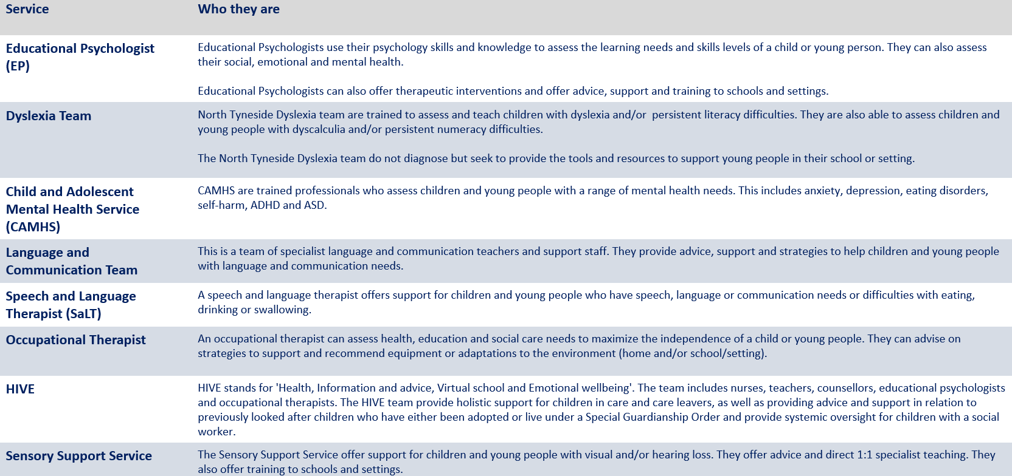

Parents will always be fully informed out the outcome of any external observations and will be given full copies of any reports. Children’s plans will be updated accordingly.

**Making Sense of SEND Jargon**

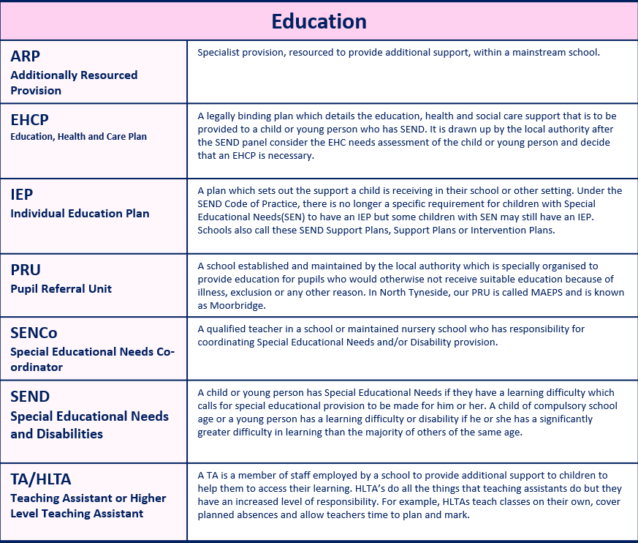

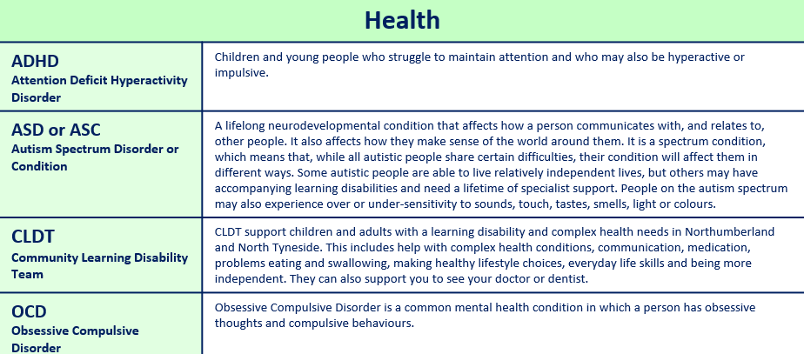

The full ‘jargon buster’ can be found at: [SEND Glossary v1.pdf (northtyneside.gov.uk)](https://my.northtyneside.gov.uk/sites/default/files/web-page-related-files/SEND%20Glossary%20v1.pdf)