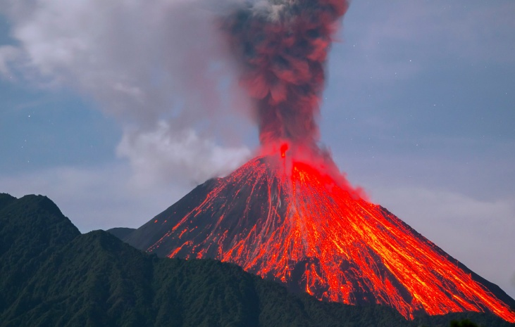

**Reading books**

* **Escape from Pompeii**
* **Pebble in my Pocket**
* **Non fiction texts- Earthquakes, Volcanoes, Tornadoes**
* **Hodgehegs by Dick King Smith**

**Year 3 Spring Term**

**Extreme Earth: What makes the Earth angry?**

**Art/DT**

* **Art-Textures and colours**
* **Mechanics – pulleys and levers**
* **Food and Nutrition – preparing and cooking healthy meals**

**Computing**

* **Animation with Scratch**
* **Databases**

**Music**

* **Charanga Music Spring Unit**

**PSHE**

* **Relationships**
* **Feelings, Emotions, conflict**
* **Healthy Relationships**

**PE**

* **Multi skills and invasion games**
* **Gymnastics**
* **Basketball**
* **gymnastics**

**History/Geography**

* **Natural Disasters**
* **Physical features of a volcano, Locations of volcanoes and why they are where they are**
* **Earthquakes and what causes them.**
* **Tornados and Tsunamis**

**Science**

* **Rocks – different types of rocks, layers of the Earth, physical properties and fossils**
* **Light – Sun safety, mirrors, shadows and reflection**

**RE**

* **Christianity – Easter Story**
* **Hinduism – gods and goddesses, Mandir feelings**

**Maths**

* **Multiplication and Division**
* **Measurement – Money**
* **Statistics**
* **Measurement - Length and Perimeter**
* **Fractions**
* **Consolidation of the four operations**

**English/writing opportunities**

* **Setting Description**
* **Narrative**
* **Diary Entry**
* **Shape Poetry**
* **Instructions**
* **Letters**
* **Leaflets – Sun Safety**
* **Explanations - Volcanoes**