**English/writing opportunities**

-Tale of Fear inspired by The Hobyah’s.

- Letter writing and a recount focussed around Dr Xargles Book of Earthlets.

- Poetry focus, mythical and dragon poems.

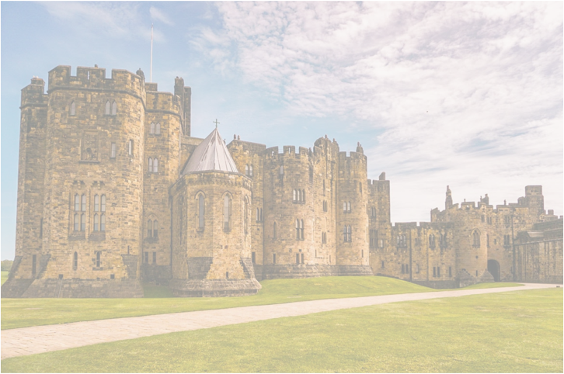

**Art/DT**

-Creating catapults, bunting and castles, -inspired by the work of artist **Friedensreich Hundertwasser.**

-Designing coats of arms, helmets and shields.

-Preparing and cooking ingredients to make soup.

**Career opportunities: Cook**

**Science**

**Plants** – Observe and describe how seeds and bulbs grow into mature plants and learn about what they need to stay healthy.

**Scientist focus:** William Walker Hunter

**Career opportunities: florist, gardener**

**Year 2 Summer**

Turrets and Tiaras



**RE**

Christianity and Judaism- comparing key stories, beliefs and key apostles/people from both religions.

**PE**

-Athletics, multi-skills and field games.

-Sports Day