Editing work on an iPad

Click on ‘Add attachment’

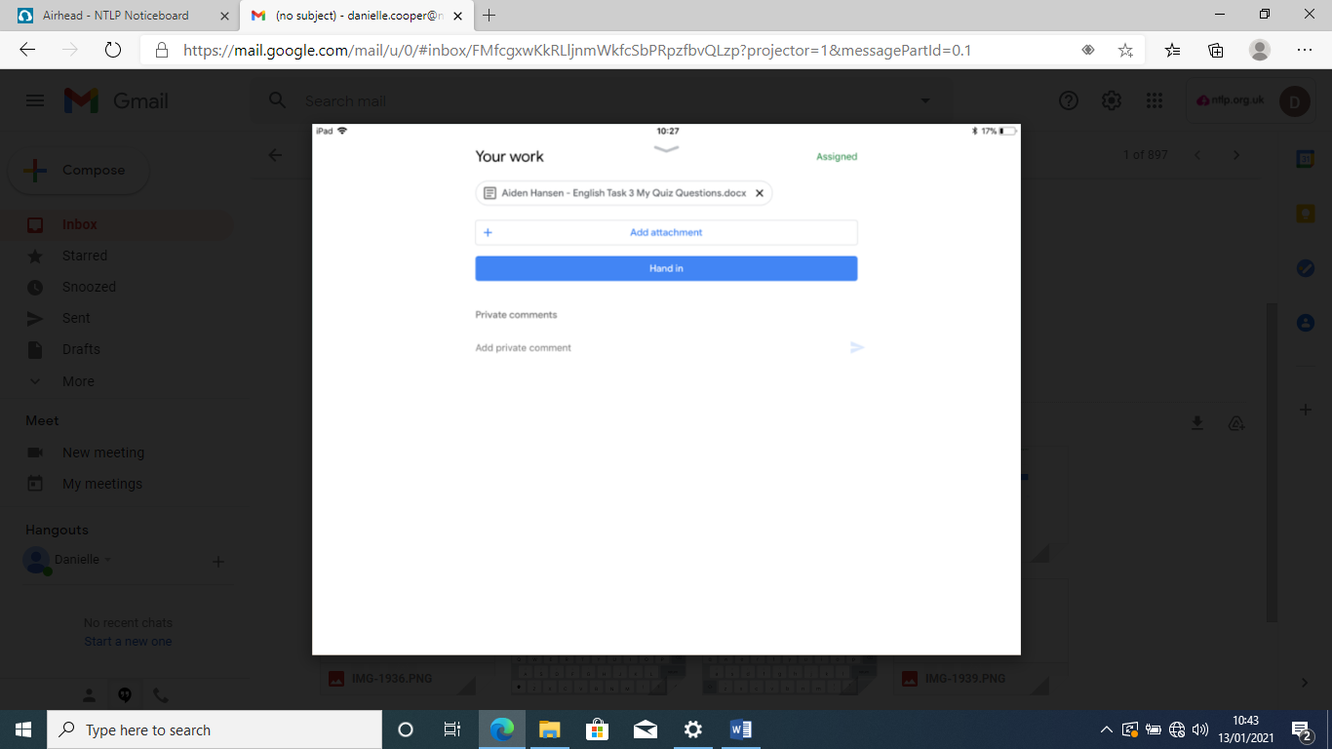

This screen will appear. You can drag the list up to be shown more options.

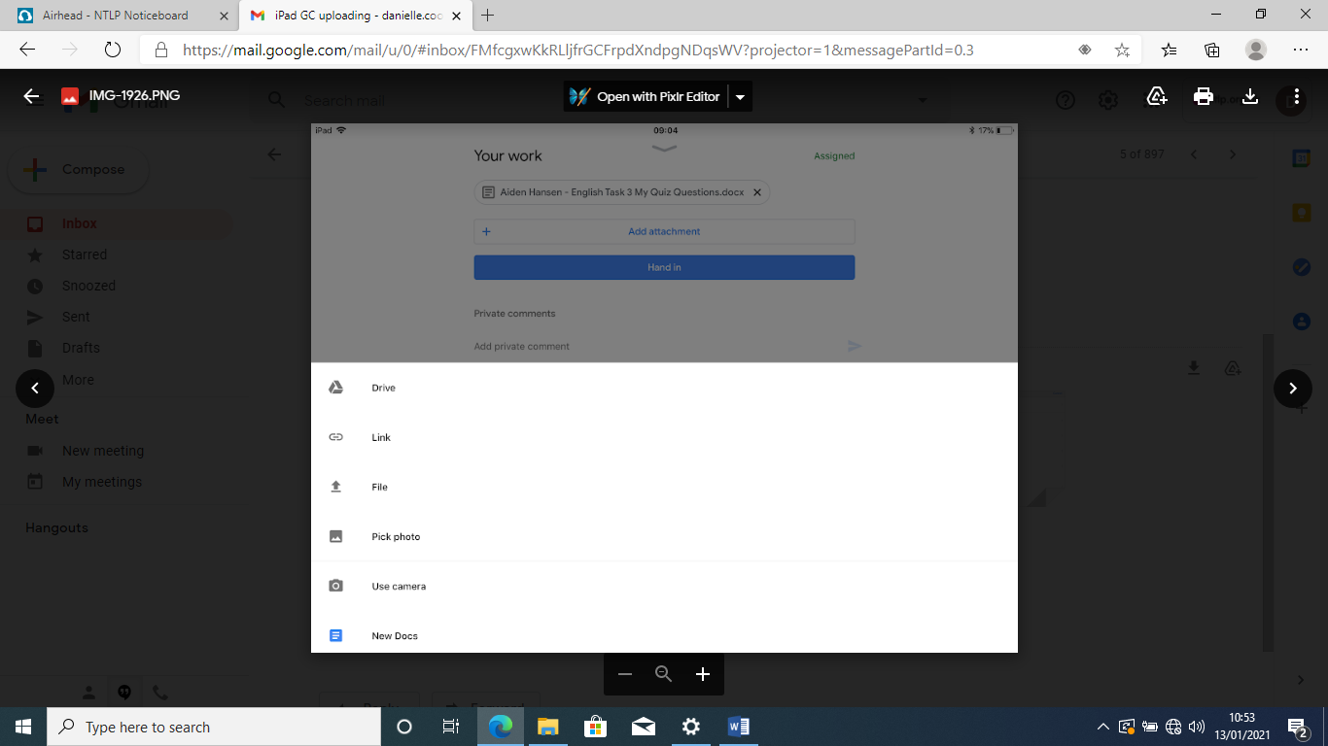

Here are all of the options available. Click on ‘New Docs’

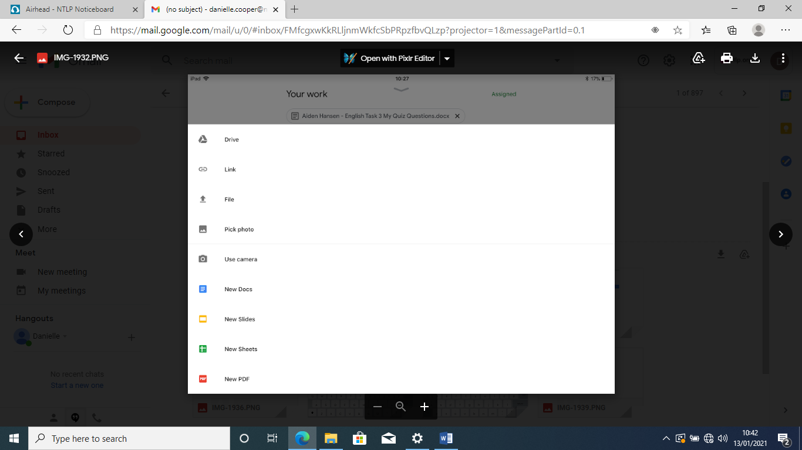

It will show you that the document is being opened

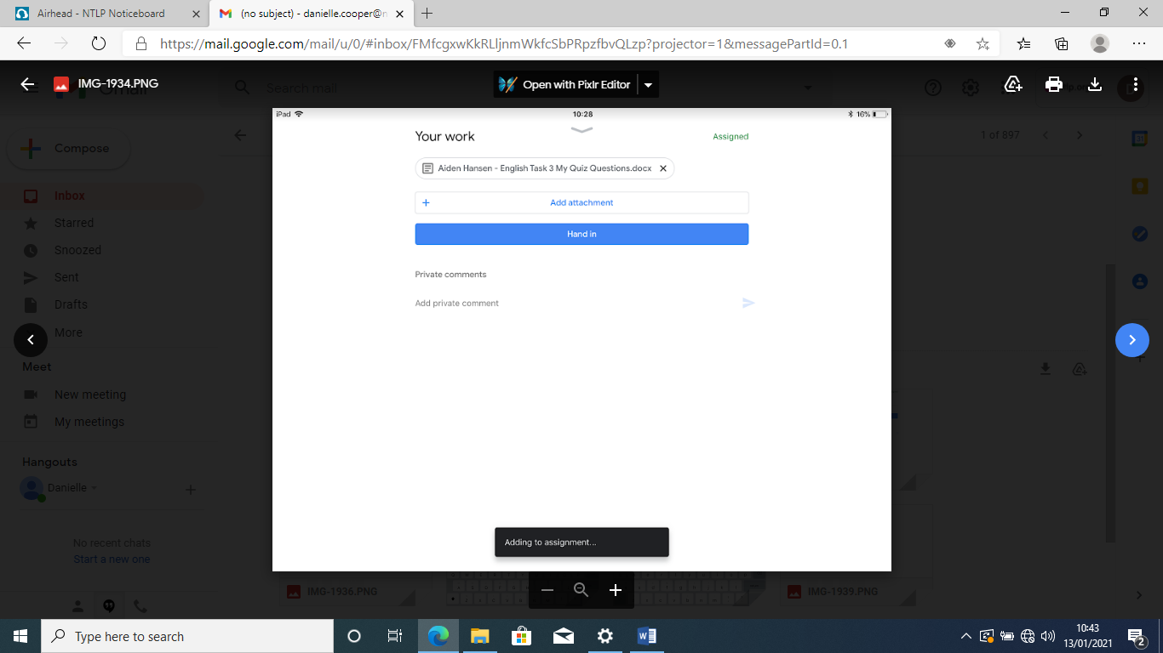

Your work will appear. Scroll through until you reach part you need to edit/add to.

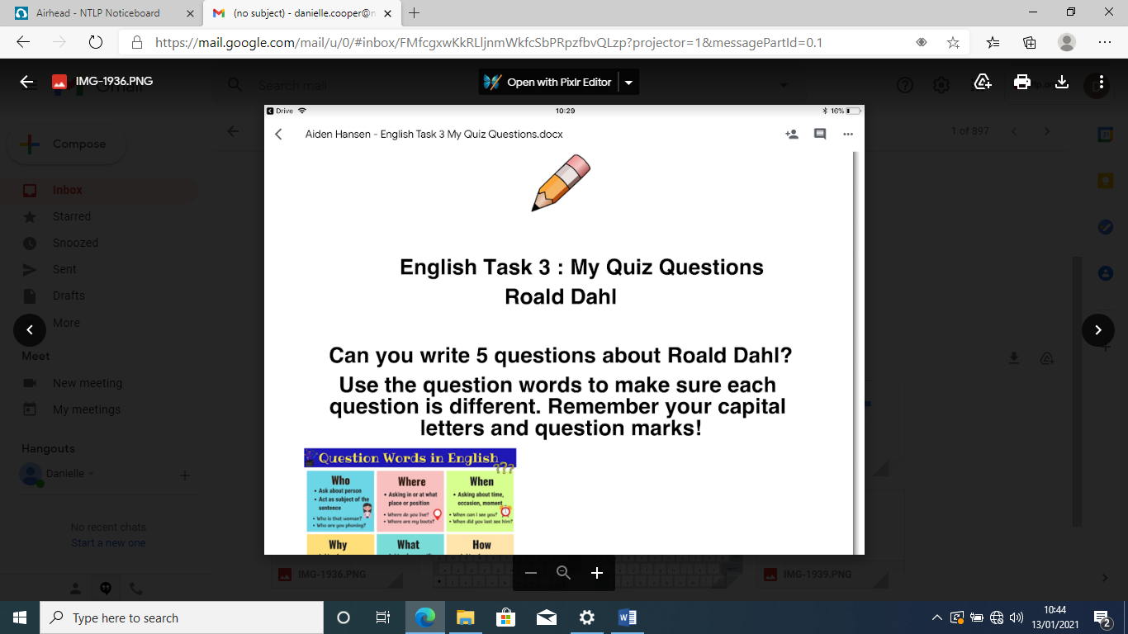

Tap on the screen and the keyboard will appear allowing you to type. You can use the bar circled below to make changes to your font size, colour and position. You can also highlight words.

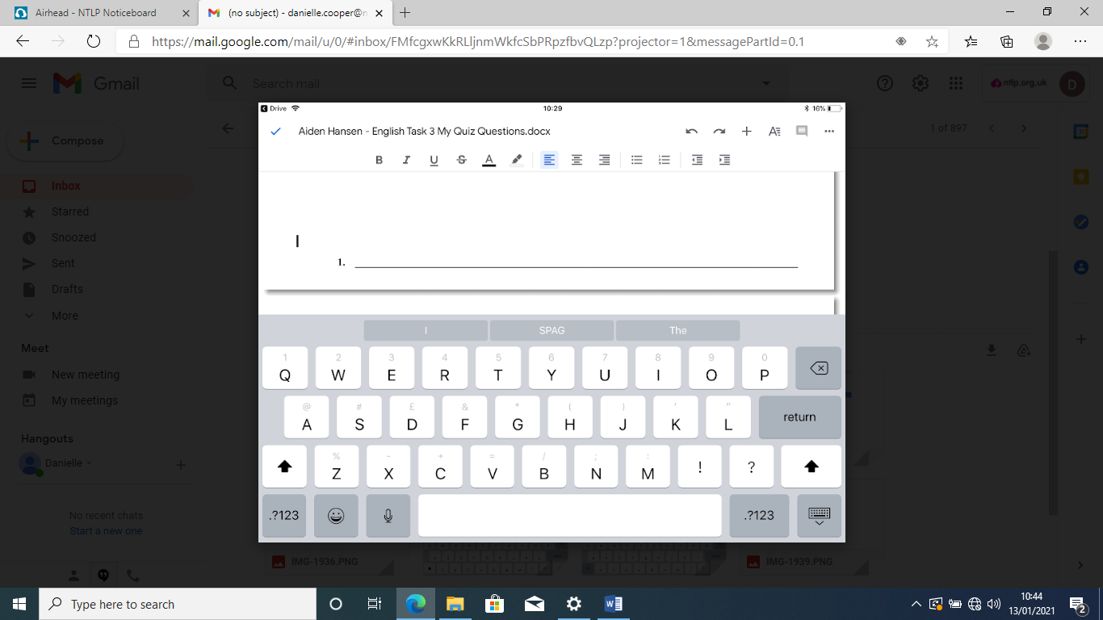

Here is an example of work being edited. When you have completed your work, click on the tick in the top left hand corner. It will save your changes to the document.

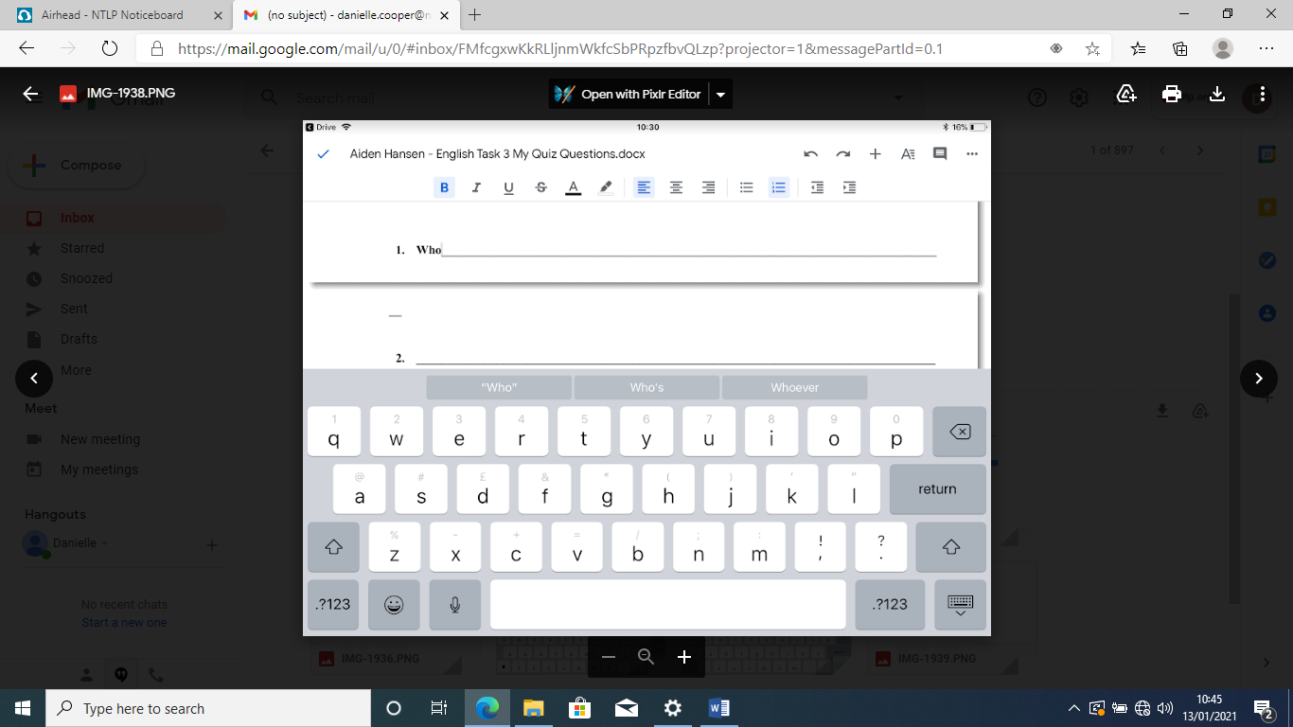

You will be taken to this screen. It shows that your document was uploaded. You then need to go back into Google Classroom

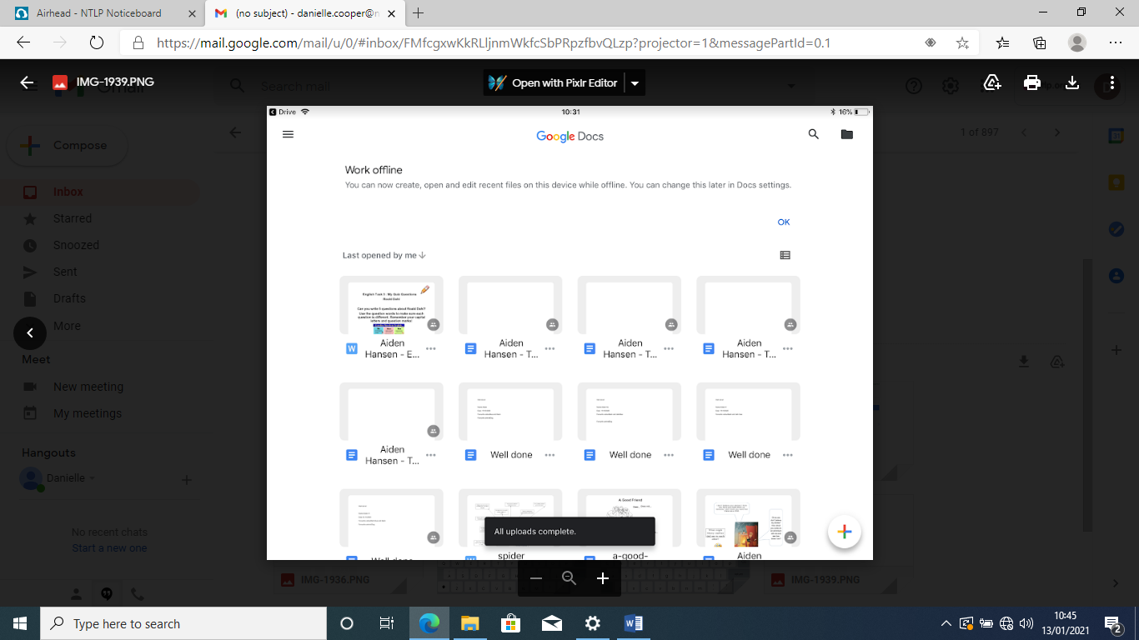

I checked to make sure it had definitely made changes, you can see below that it worked.

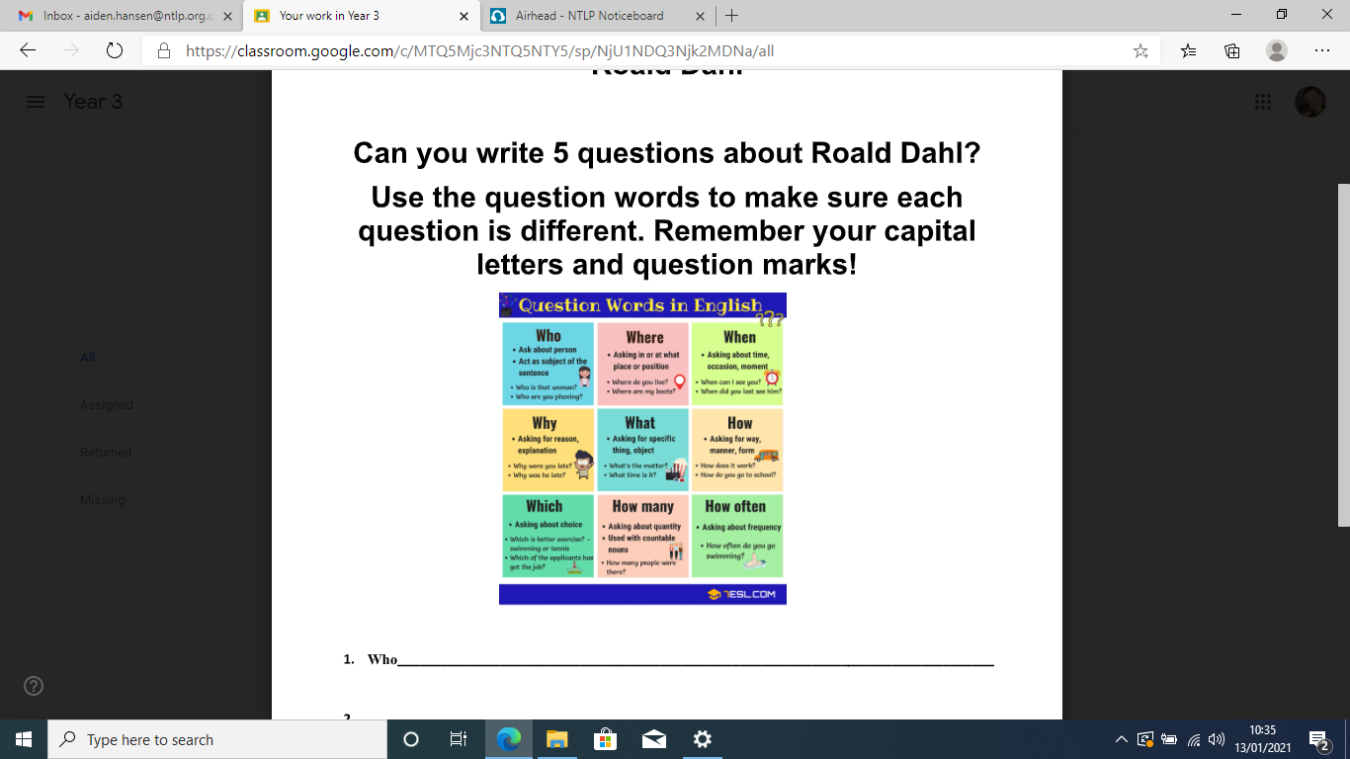

When you get back to your assignment on Google Classroom, you need to click ‘Hand in’ which will bring up this sign. Click on ‘Hand in’ again and your work will be ready to be marked by your teachers.

