Uploading work from an Android phone

From the Google Classroom main stream click on ‘Classwork’

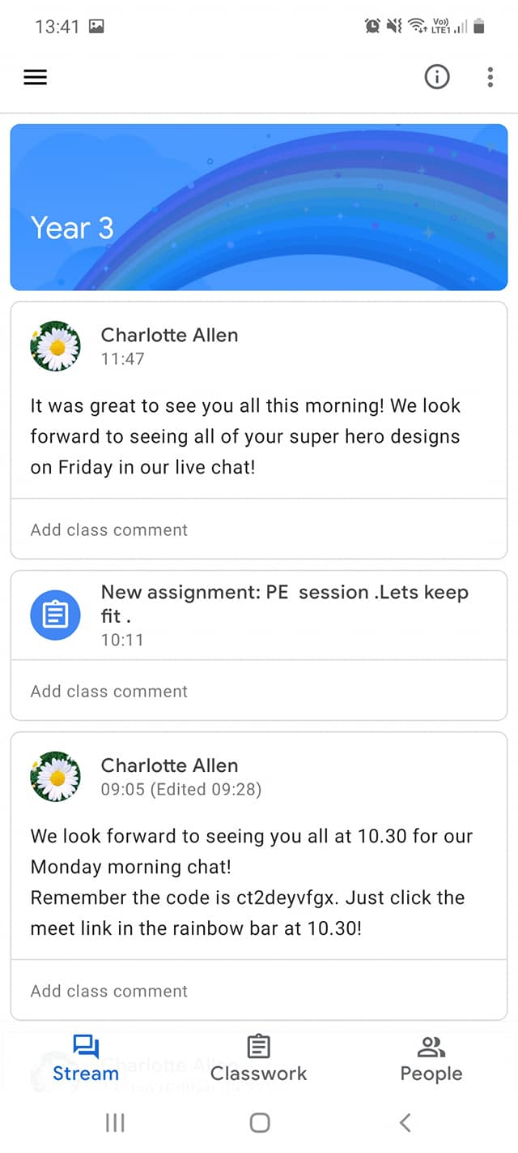

Select the assignment you want to upload work to

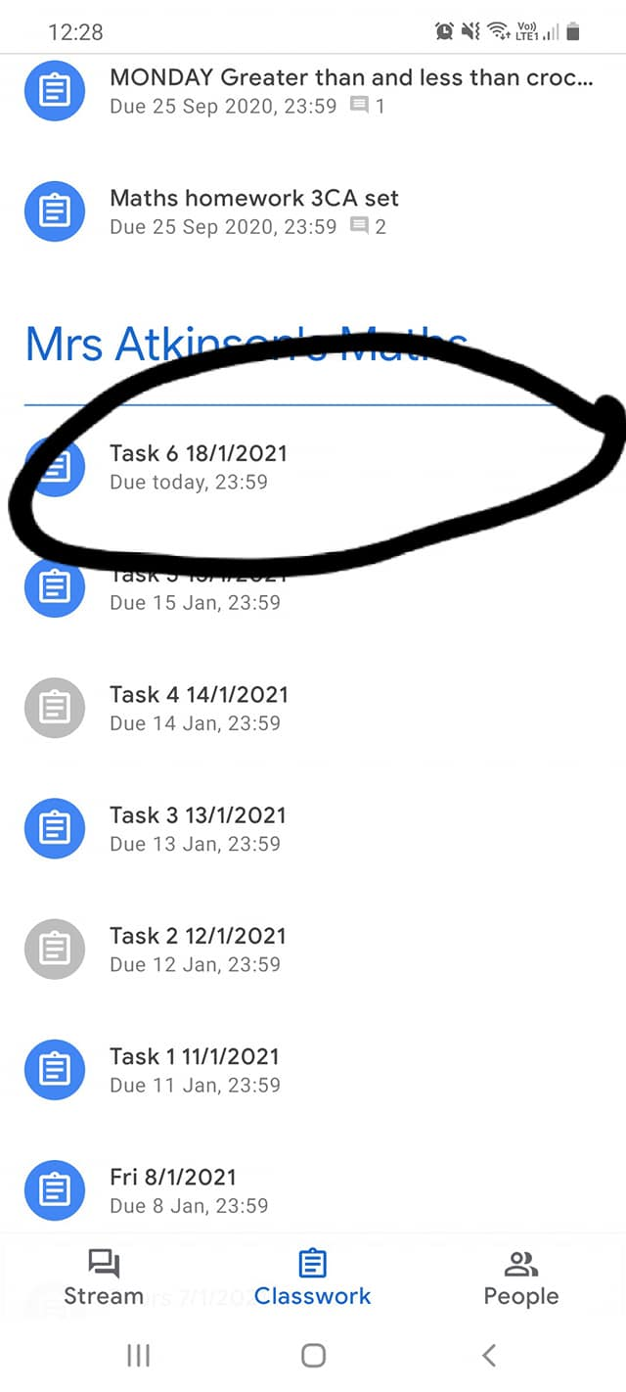

Click on ‘Your work’

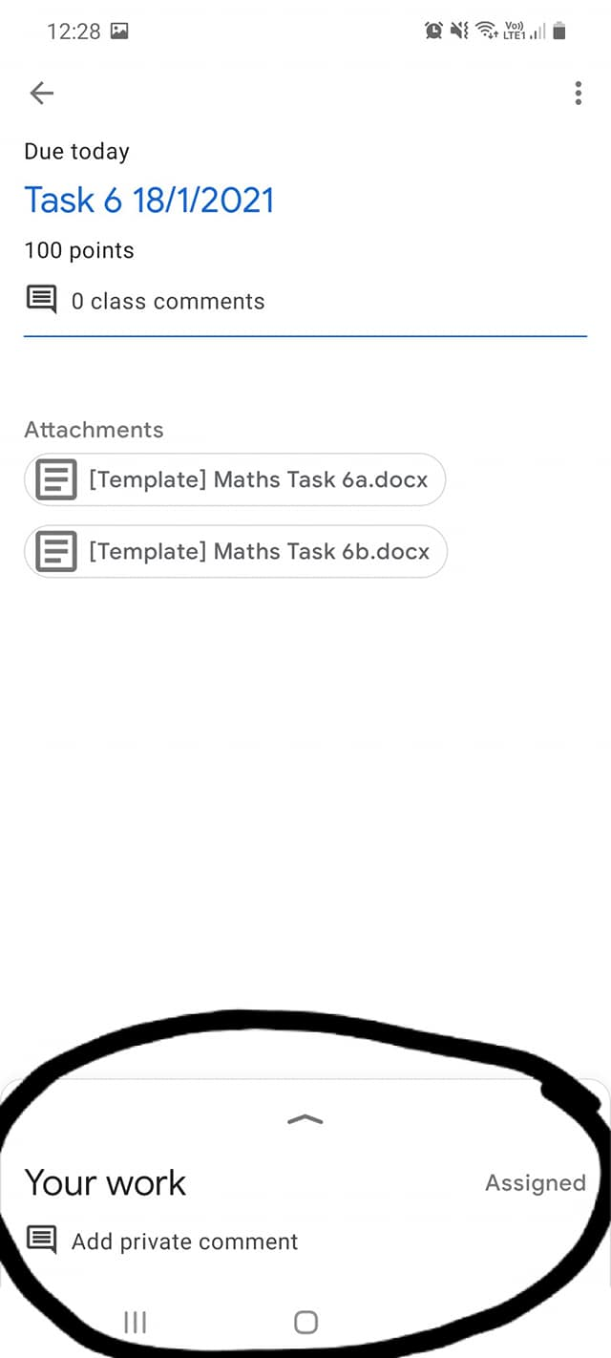

Select ‘File’

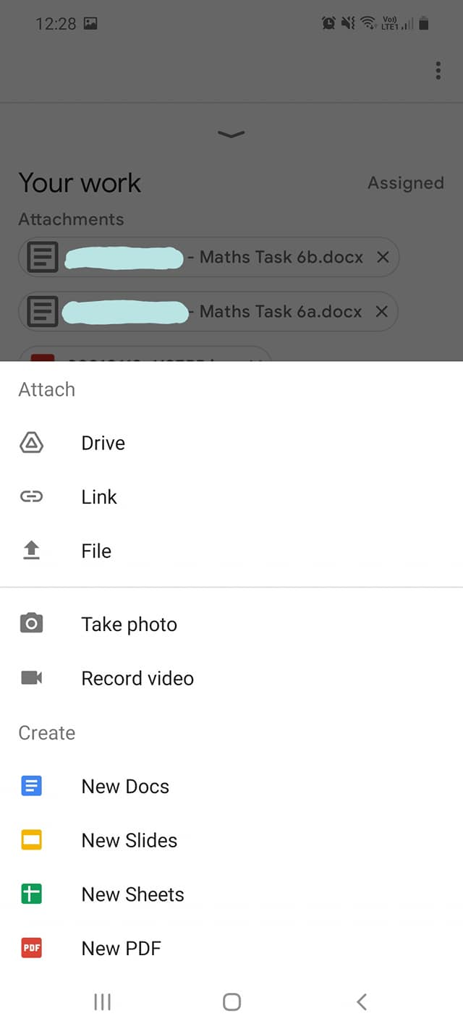

Select the document you want to upload

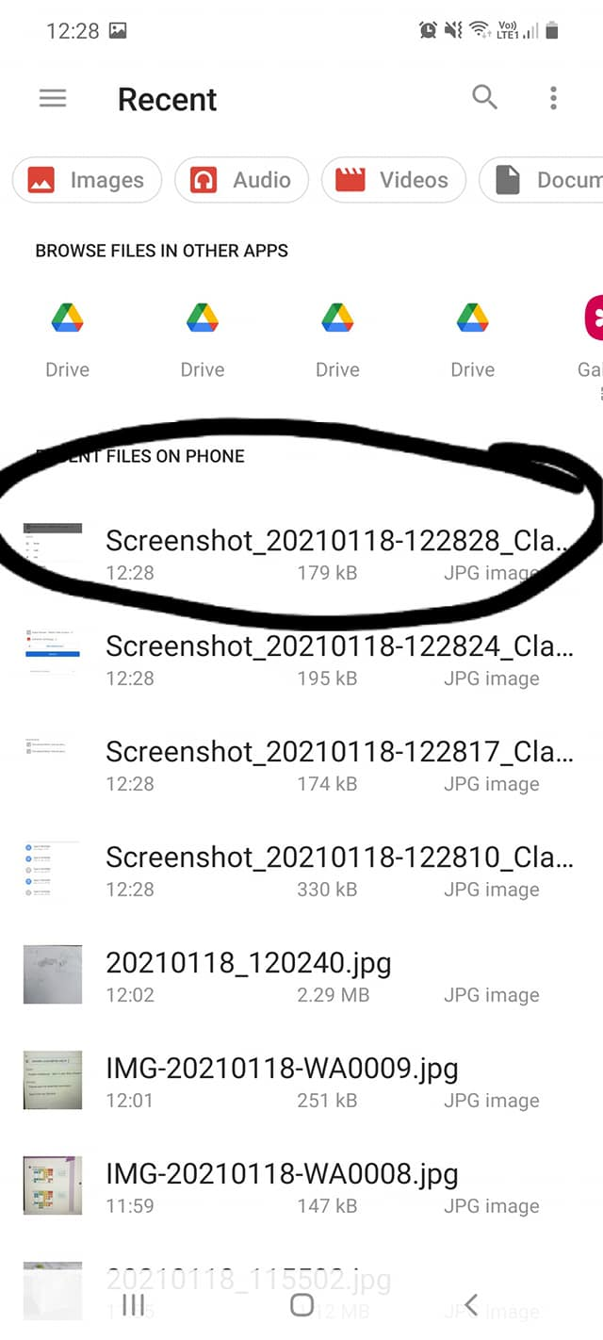

Work will appear after a few seconds. If it doesn’t you can click off this screen and go back in to see if the upload has appeared.

Repeat previous steps if you have additional work to add. Then click ‘Hand in’

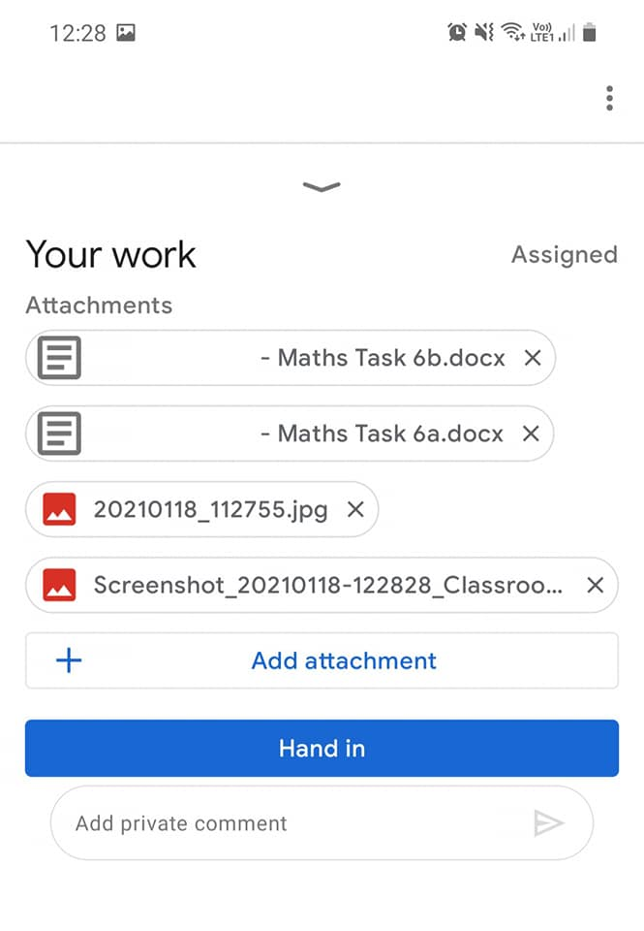

This message will appear, click ‘Hand in’ for your teachers to receive your work

