

Differentiation for Inclusive Teaching

**Quality First Provision   
Social, Emotional and Mental Health**

* A clear and understood behaviour policy, detailing our ‘restorative justice’ system as well as rewards, sanctions and behaviour charts.
* An environment where pupils feel safe and free.
* A range of opportunities to support social and emotional development: nurture time, ‘Me time’, PSHE circle times, school nurse involvement, outside agency involvement (where applicable) as well as positive and trusting relationships with staff.
* Consistent use of positive language and clear expectations from adults.
* Consistent visuals used throughout the school to show children expectations at all times.
* Positive, regular communication with parents and carers
* A curriculum that takes into account concentration levels – chunked activities, visuals, allowing for extra time when needed, movement breaks and ‘ME time’.
* Tactile sensory objects to calm students including, weighted jackets, chew toys, weight blankets and small fidget toys.
* Time Out and movement breaks.
* Recognition of sensory needs and appropriate adjustments made e.g. ear defenders / chew toys / movement breaks.

**Quality First Provision**

**Cognition and Learning**

* A curriculum that is relevant to pupil’s level of attainment or development, where the pupil is aware of the next steps in learning.
* Children (where appropriate) take ownership of their targets within their SEND plans – allowing them responsibility and talking through why we need to work towards theses to give relevance.
* Curriculum differentiated by changing presentation, task or outcomes (as appropriate to learning)
* Reading materials modified and accessible to students.
* Students can present knowledge / views in a variety of ways e.g. visually, with a partner, through conversation, visually, and through creative and drama activities.
* Accessibility to personalised learning aids such as word banks and other visuals created on Widget.
* Repetition and reinforcement of skills
* Visually supported learning environments
* Multi-sensory approaches to learning
* Methods to summarise and highlight key teaching points (POP activities)
* Questions differentiated in accordance to level of understanding and emotional needs
* Teaching adapted to a range of learning preferences due to all staff having an excellent understanding of children’s needs.

**Quality First Provision**

**Communication and Interaction**

* Clear and simple instructions
* Clear classroom organisation and consistent routines.
* Clear explicit use of language
* Time provided for pupils to process language / instructions
* Outcomes modelled and demonstrated
* Opportunities to work independently at own individual pace
* Visual timetables and supports *e.g. Now and Next boards, ‘my adult working with me is’, behaviour charts.*
* Access to talking partners or working alone if preferred.
* Strategies and approaches to manage change and transitions.

**Quality First Provision**

**Sensory and Physical Needs**

* Environmental adaptations to suit cohort or individual pupils (Sensory audit conducted by SENDCo and Educational Psychologist).
* Access to specific equipment and resources to support learner.
* Awareness of seating positions to take into account sensory difficulties *e.g. hearing or sight*
* Effective use of resources and technology (ipads / chromebooks / widget)
* Support as detailed in SEND plan or Education Health Care Plan (EHCP).

**Teaching Strategies for Dyslexia**

* Use of visual, interactive displays and allow knowledge to be gained by pictorial representation
* Instructions should be clear and short
* Provide opportunities for clarification and reinforcement
* Reproduce material in different ways so that it is actively processed, i.e. if giving information verbally also make it into a mind map or diagram etc.
* Use a variety of methods to record work, ipads, mind maps, working on whiteboards (and photocopy as evidence), HA/LA peer partner work, voice recording and drama.
* Working with a partner to take pressure away, using strengths collaboratively.
* Use of writing frames and key word mats.
* Give students a reminder that only ___ minutes left of the lesson. Use visual timer.
* Allowing for extra time if needed.
* 2/3 times per week 1:1 dyslexia interventions to support progress and confidence (coincides with RWI lessons so can apply this in their lessons – making the link and building pupils confidence).
* Word / sound mats readily available on all student desks.
* Dyslexia friendly overlays / books and glasses to support pupils when reading and writing.
* Effective use of additional adult support when needed.
* Ensure all students’ are clear about the objectives of the lesson and can explain it verbally.
* Writing slopes, pencil grips and weighted wrist supports for children who need them (OT involvement).
* Yellow ‘over write’ available to support letter formation – red arrow used to show student where they need to start with their pencil.

**ADHD: Teaching Strategies**

* Small and subtle fidget toys e.g. Lego tape attached to underside of table for children to ‘fiddle with’ whilst listening to teacher input.
* If a student has difficulty sitting for long periods at a desk, let them stand or allow for a ‘movement break’ (child to run a small ‘errand’ for staff)
* Limit the amount of waiting time to a minimum wherever possible and minimise the length of time the child has nothing to do (pace of lesson / well planned).
* Break long lessons into easily achievable steps to encourage a sense of completion.
* Provide access to an independent area away from the group to complete tasks, e.g. on their own table or in the art area.
* Keep noise levels down and have periods of silence. Try to eliminate any background noises
* Appropriate quiet music can have a calming and focusing effect.
* Frequent reinforcement of positive behaviour.
* Ensure that feedback and rewards are immediate – long term goals will not work.

**Autism Spectrum Disorder (ASD):**

**Teaching Strategies**

* Build in routines, familiar introductions / activities to begin lessons.
* Teachers are predictable and consistent.
* Students do not necessarily need to look at you to hear what you are saying.
* Some students’ may gain comfort by asking the same questions over and over (Repeated questions are often a sign of stress).
* Teach strategies to enable the student to achieve independence.
* Use of relaxation techniques for all of the class *e.g. soft music / quiet working time.*
* ‘Withdrawal’ strategies are used to enable the student to ‘escape’ to quiet areas or activities when anxious, angry or stressed
* Identify the strengths and interests of the student and use them to motivate
* An awareness of sensory needs that the student may be super sensitive to touch, noise, smell, light, taste, close proximity of other people
* Celebrate success – no matter how small!
* Use the student’s name to get their attention before speaking to them.
* Introduce new items of information, using an association with a favourite object, word or image.
* Use role-play often, promoting body language and expression to different situations.
* Keep to a routine so that the student understands why things are happening and how to cope with small changes in the day
* Give explicit instructions and clear/unambiguous statements
* Use visual timelines / Now and Next boards as visual reminders for the student
* As transition approaches, give a warning
* Give information and cues to prepare for what is coming next.

**The Graduated Approach**

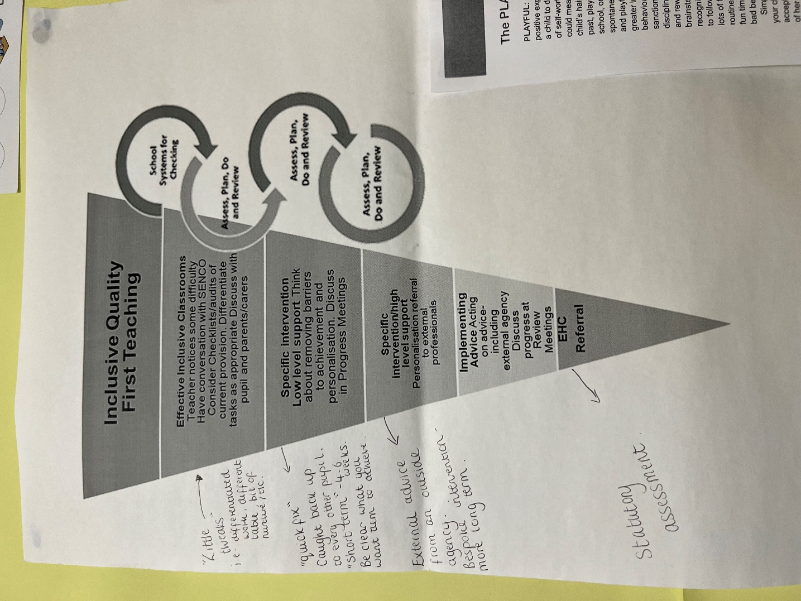

**SEND plans**

**(Assess, Plan, Do, Review)**

* Understanding of pupil’s needs
* Pupil’s views (Pupil Voice)
* Parent’s / Carers views
* Long term, overarching aims for a child (which could be targets that stay with them throughout their time at Collingwood).
* 2/3 SMART targets that are appropriate to suit and support child’s ability and needs. (Worked on throughout Autumn 1,2 and Spring 1) then reviewed and changed (if needed) for the rest of the school year.
* Quality first approaches / resources to be used consistently in lessons.
* List of targeted interventions the child receives.

**Effective Use of TA’s**

The role of the TA at Collingwood is not as a Velcro-adult to an individual or group. Their role is to support all of the pupils in the class; to enable the teacher to give direct teaching to individuals or groups; to facilitate an individual to become an independent learner; to deliver high quality measurable interventions; to support a range of individuals or groups at different times; to deliver bespoke interventions around an individual’s identified needs; to adapt learning resources and to help individuals select resources to support their own learning

Having a TA attached to one child is not productive to that child’s learning, progress or social development. This can often prevent a child from gaining independence and does not help child development

Do not be deflated if approaches take time and practice.

SEND has no set way.

It is all built on trial and error in using tried and tested strategies.

Patience is key.

* At Collingwood, we encourage all children, whatever their needs, to strive and achieve to be the best they possibly can and embrace them for all the qualities that make them who they are.
* Special Educational Needs is not about the student being different. It is about different people learning in different ways.

Always consider what YOU might need to change in order to support the needs of the student.

Miss McConnell

SENDCO