**Uploading work to Google Classroom from an iPad**

When you have clicked onto the assignment you want to upload work to, click on ‘Your work’ at the bottom

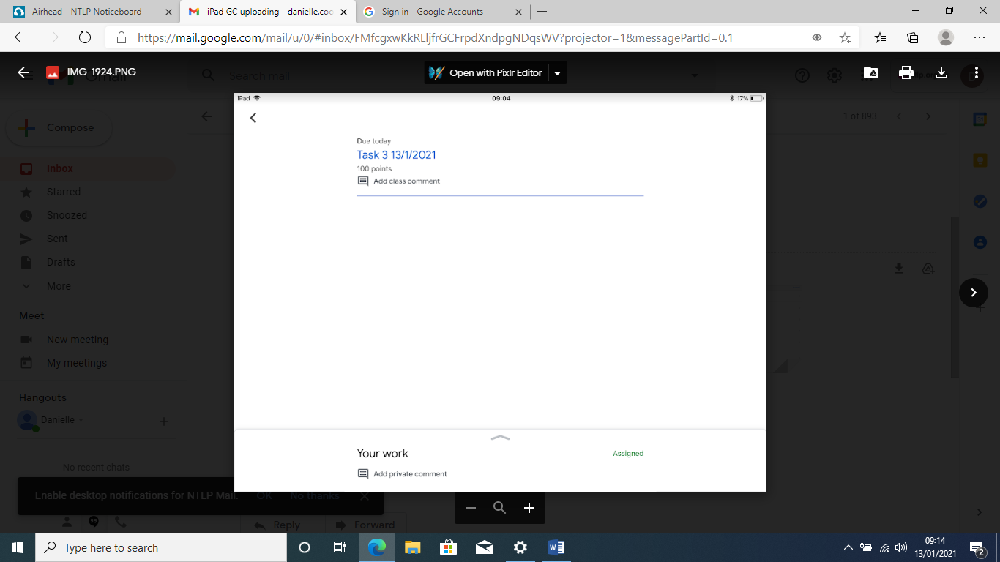

Click on ‘Add attachment’

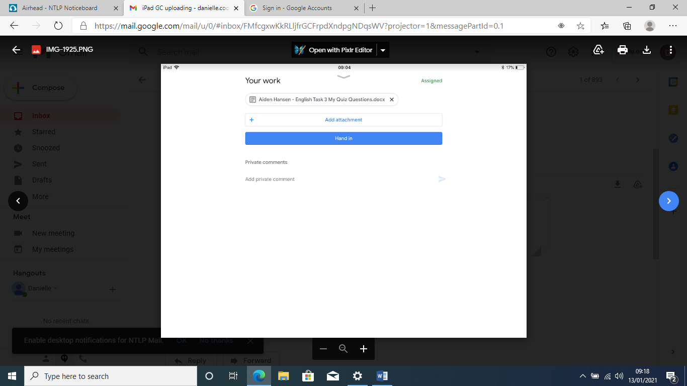

This screen will appear. Click on ‘Pick photo’ which will take you to your photos gallery

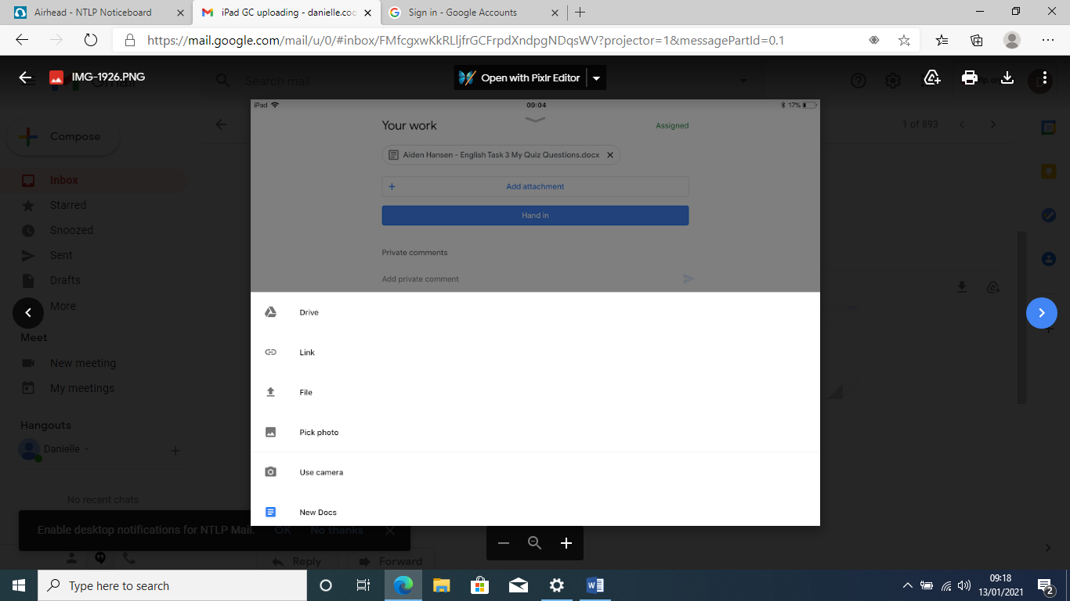

Click on the folder which has your work in. I would click on ‘Camera Roll’ if you took a photo of your work or ‘Screenshots’ if you took screenshot.

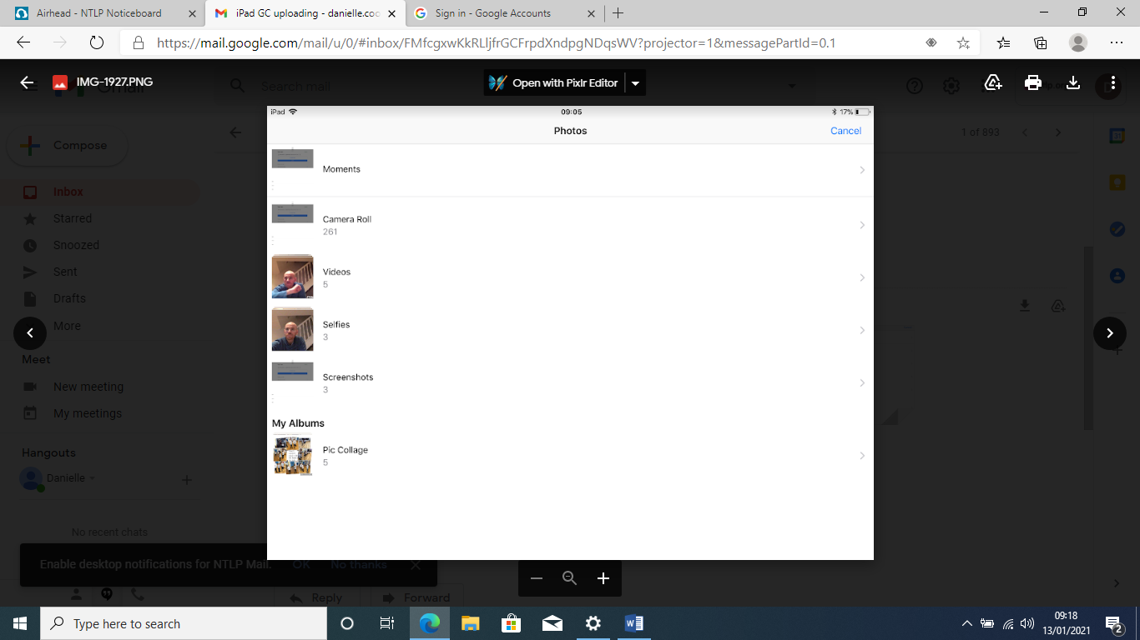

Select the piece of work you want to upload

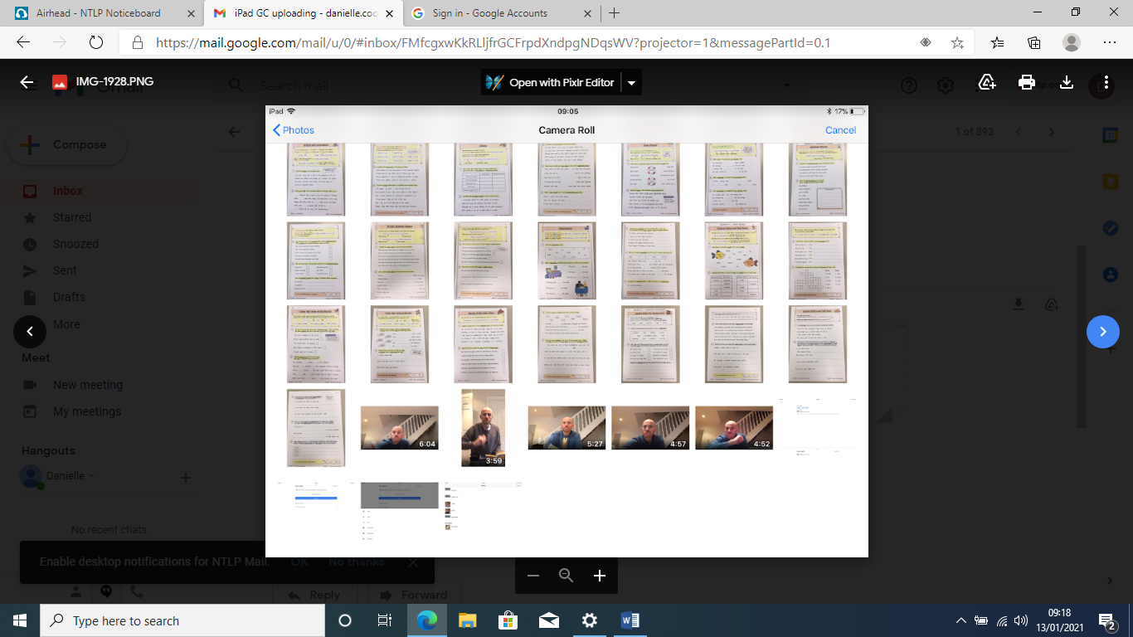

This screen will appear when you have clicked on the work you want to upload

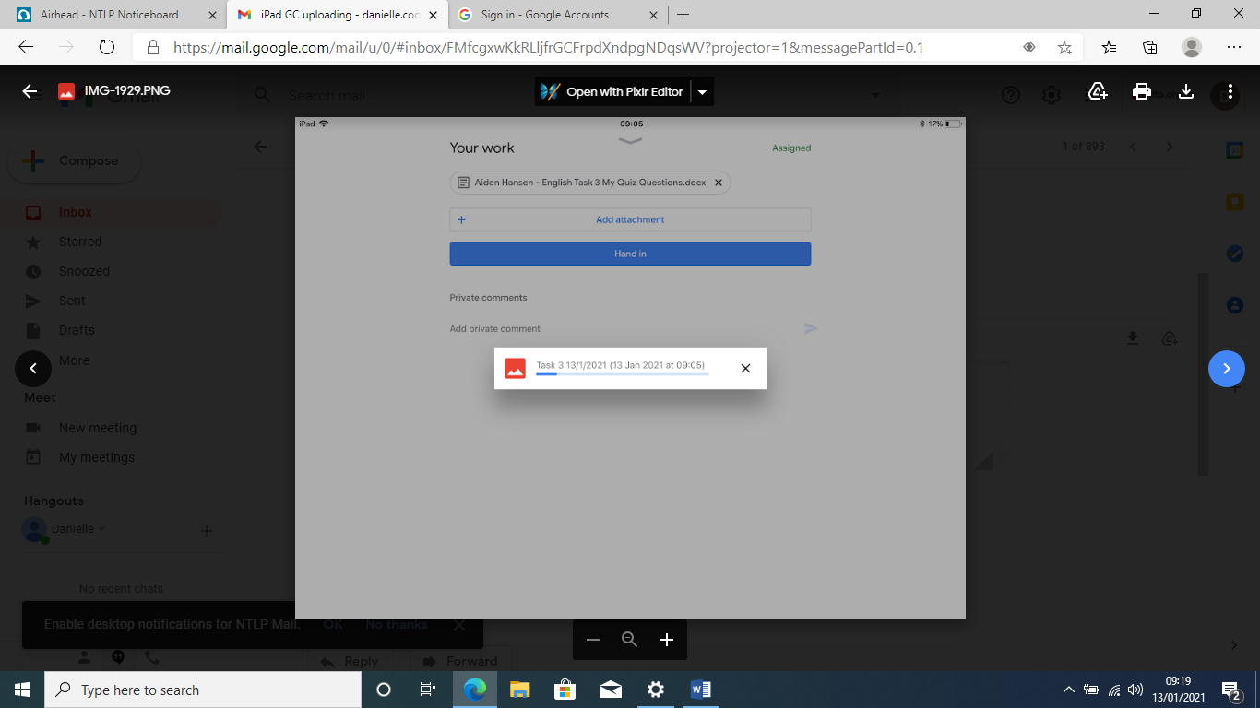

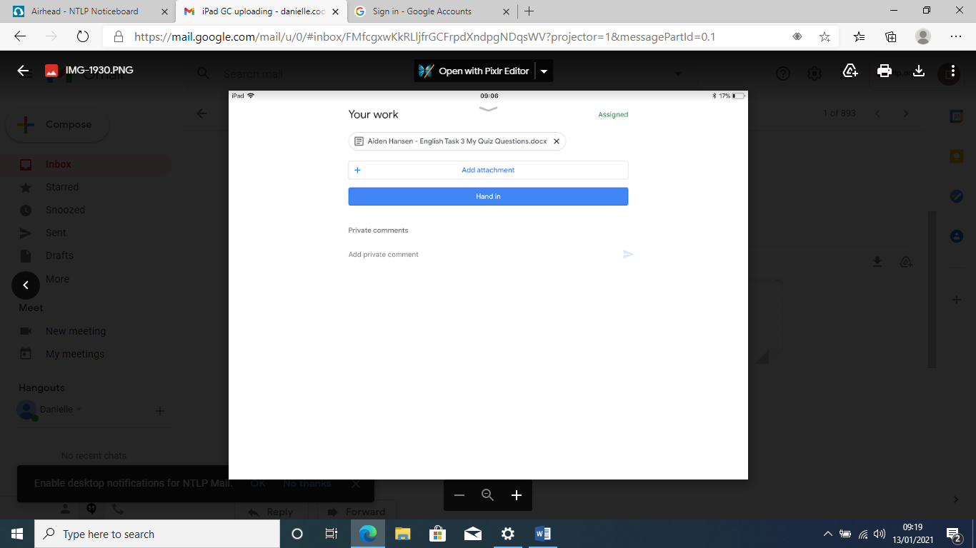You will be taken back to this screen. If you have multiple images you want to upload, you will need to repeat the earlier process. When you have uploaded everything, click ‘Hand in’.

It will show up with the number of attachments you have uploaded. Click ‘Hand in’ and your teachers will receive your work.

