Writing at Collingwood Primary School    Our Writing provision aims to foster a passion for writing which recognises its value in communicating with, and entertaining and engaging others. We strive to broaden our pupils’ vocabulary providing them with the skills and techniques required to become fluent and confident writers. | Content and Sequencing  EYFS – In EYFS children develop early writing skills, providing them with strong foundations and the knowledge they need to enable them to be successful writers.  KS1 & 2 – We follow the National Curriculum programmes of study to plan, sequence and teach our lessons: progression of skills  Spellings – We follow the National Curriculum programme of study to plan and sequence the teaching of spelling: English Appendix 1 - spelling  Handwriting – We follow the Nelson Handwriting Scheme.  Composition – We make links across the curriculum, planning texts which relate to our termly topic, where possible. From Year 2 onwards, we use whole class readers each term and theme our writing around the text.  Vocabulary – We build vocabulary using: word of the week, repetition, contextual understanding, sentence building, synonym & antonyms and through the use of fun games using a Tier 3 model approach. | Essentials  - Transcription (spelling and handwriting) –spelling accurately; knowing the relationship between sounds and letters (phonics) and understanding morphology (word structure) and orthography (spelling structure).  - Composition (articulating ideas and structuring them in speech and writing) –  forming, articulating and communicating ideas; organising them coherently for a reader. Requires clarity, awareness of audience, purpose and context.  - Vocabulary, grammar and punctuation –  - increasingly wider range of vocabulary and grammar; understanding nuances/relationships between words, enabling more conscious control and choice over language
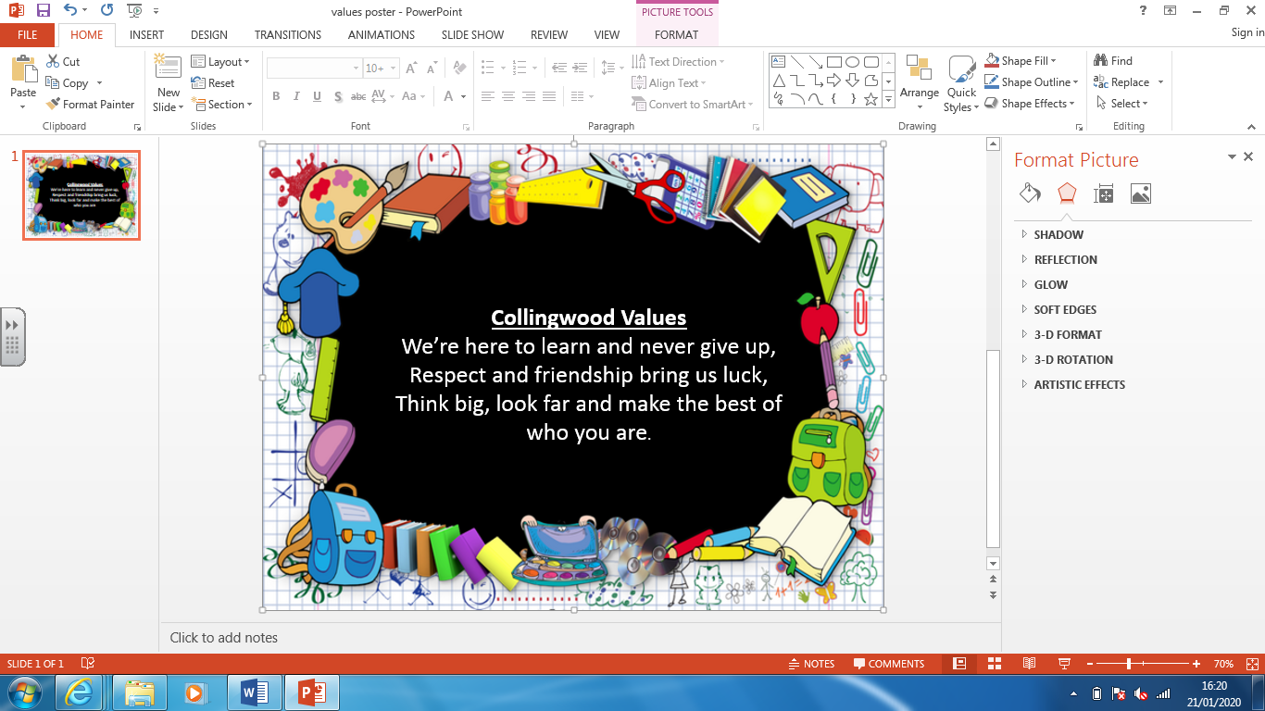

Progress
Units of work are carefully sequenced so prior knowledge and concepts are built upon.
Regular formative assessment and immediate feedback ensures gaps are filled.
Effective questioning and higher order thinking are embedded within all learning experiences.
Progress and attainment within units is recorded and shared with all teaching staff.
Opportunities for revisiting content or apply learning in greater depth. Key ideas, concepts and facts recorded in knowledge organisers.

