Sending edited work from an Android phone

From the Google Classroom main stream click on ‘Classwork’

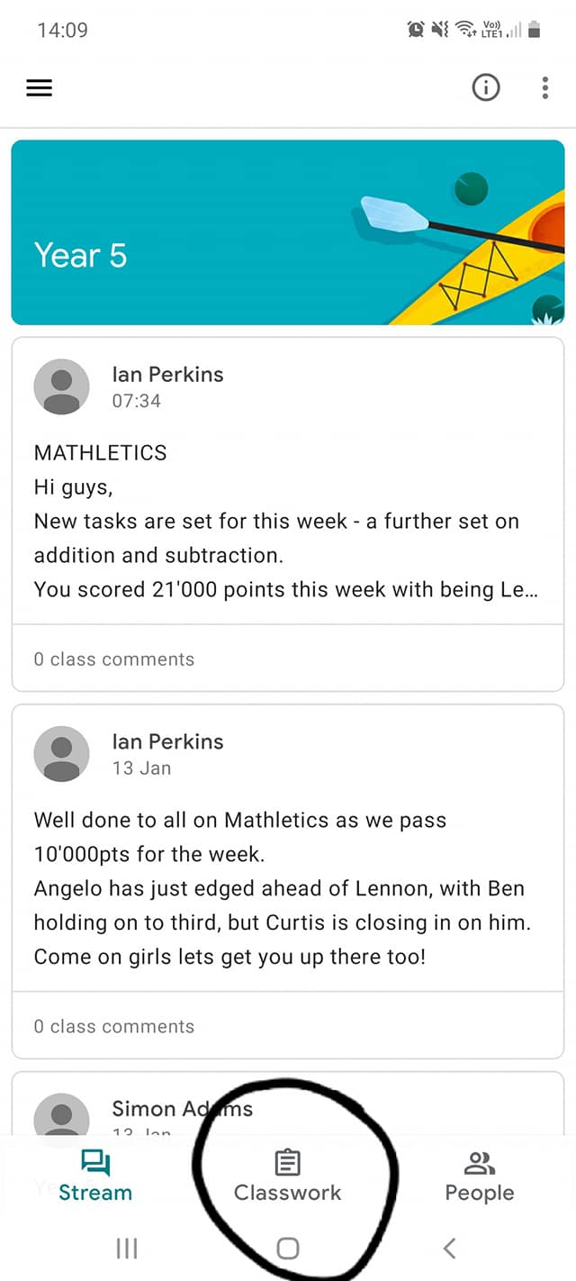

Select the assignment you want to edit

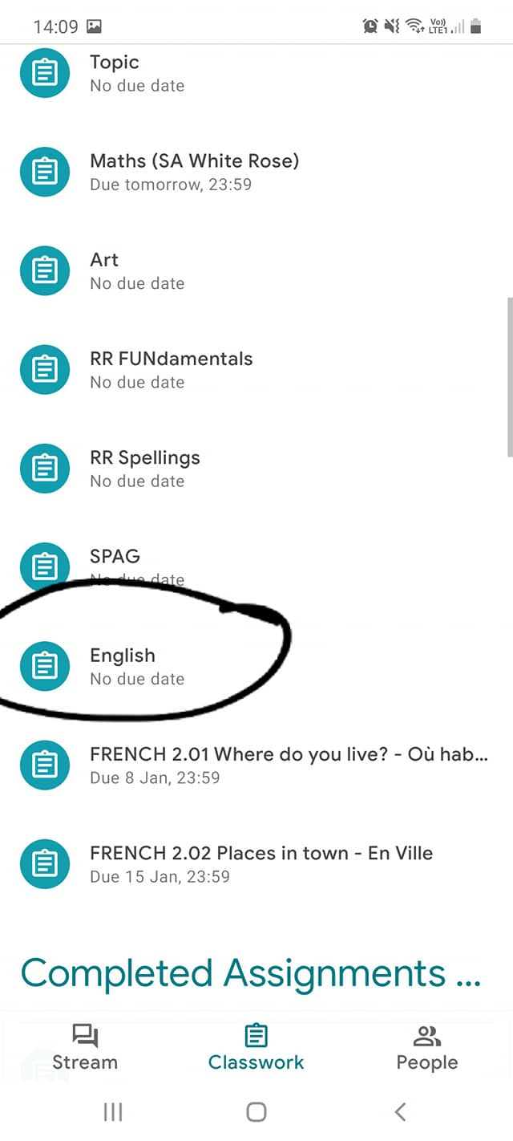

Either click on the ‘Attachments’ or ‘Your work’ to get access to the document you want to edit

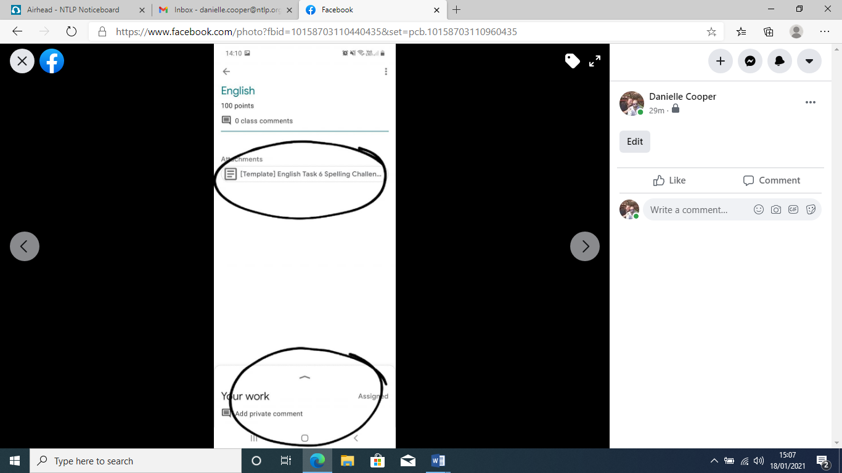

If you clicked on ‘Your work’ you will be taken to this screen. Click on the ‘Attachment’ you want to open

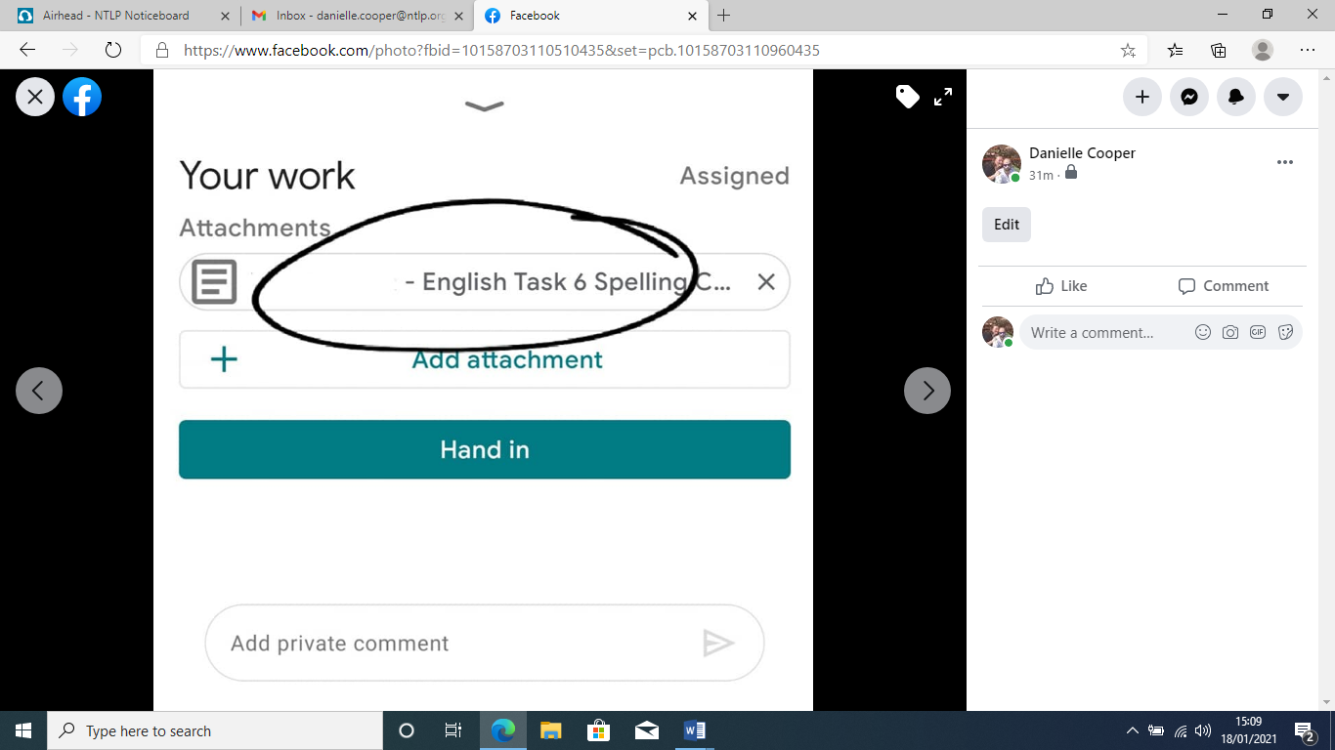

To open the document for editing - click on the 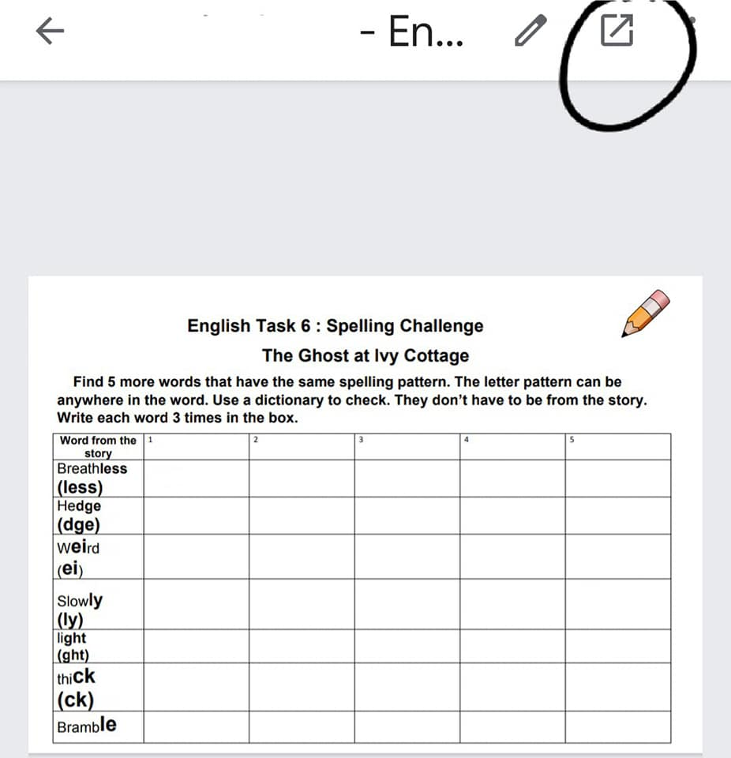icon in the top right hand corner



Next, click on the ‘pencil’ in the bottom right hand corner to edit work

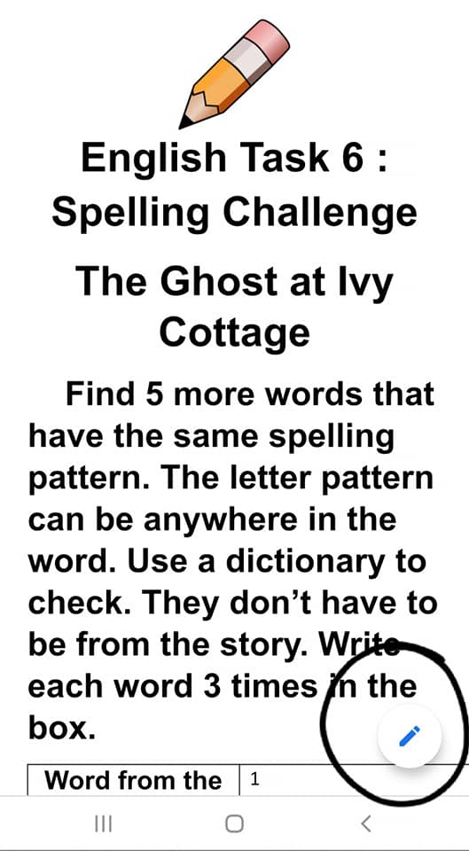

The keyboard will appear when you click on the space you want to edit. When you have completed your work, select the tick in the top left hand corner to save all changes

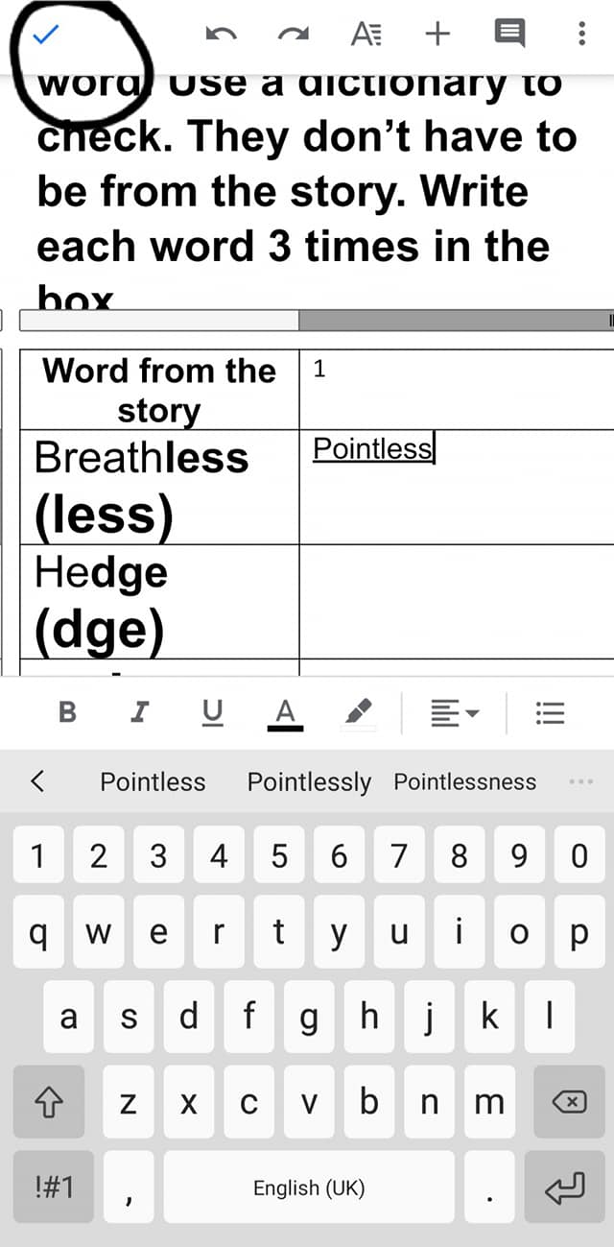

To share your work you need to click on the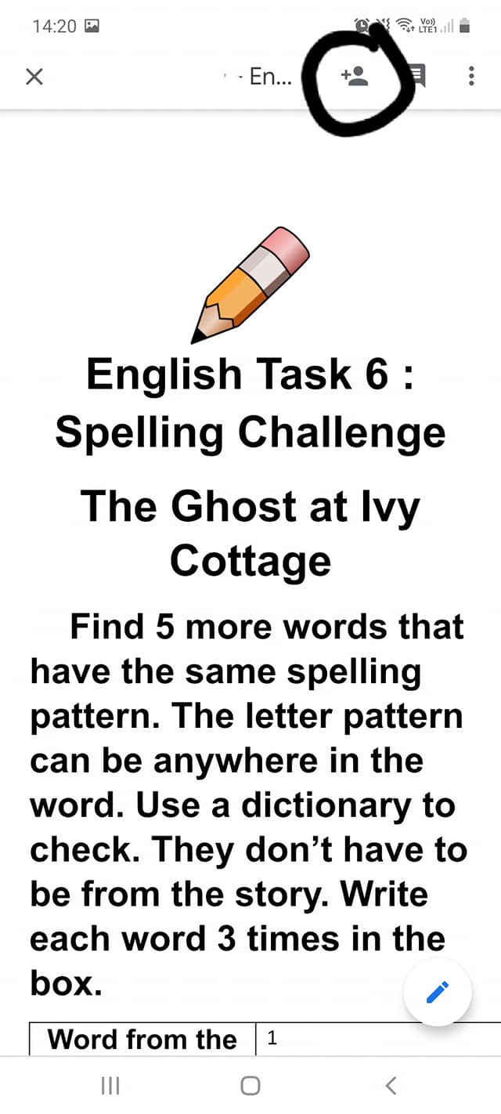icon



Click in the ‘Add person or groups’ section and type in the name of your teacher(s)

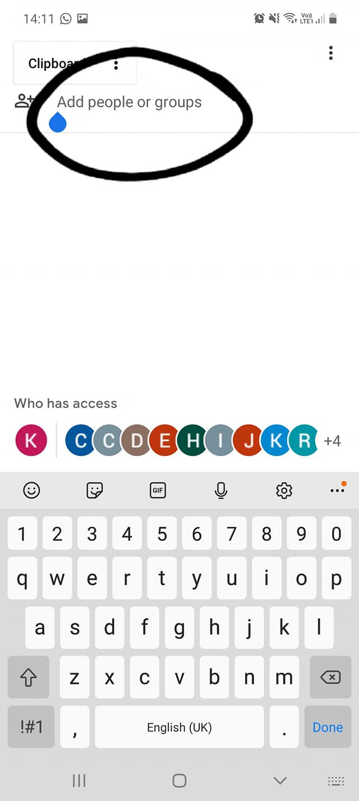

A list of names will appear. Be sure to select the correct email address for your teacher

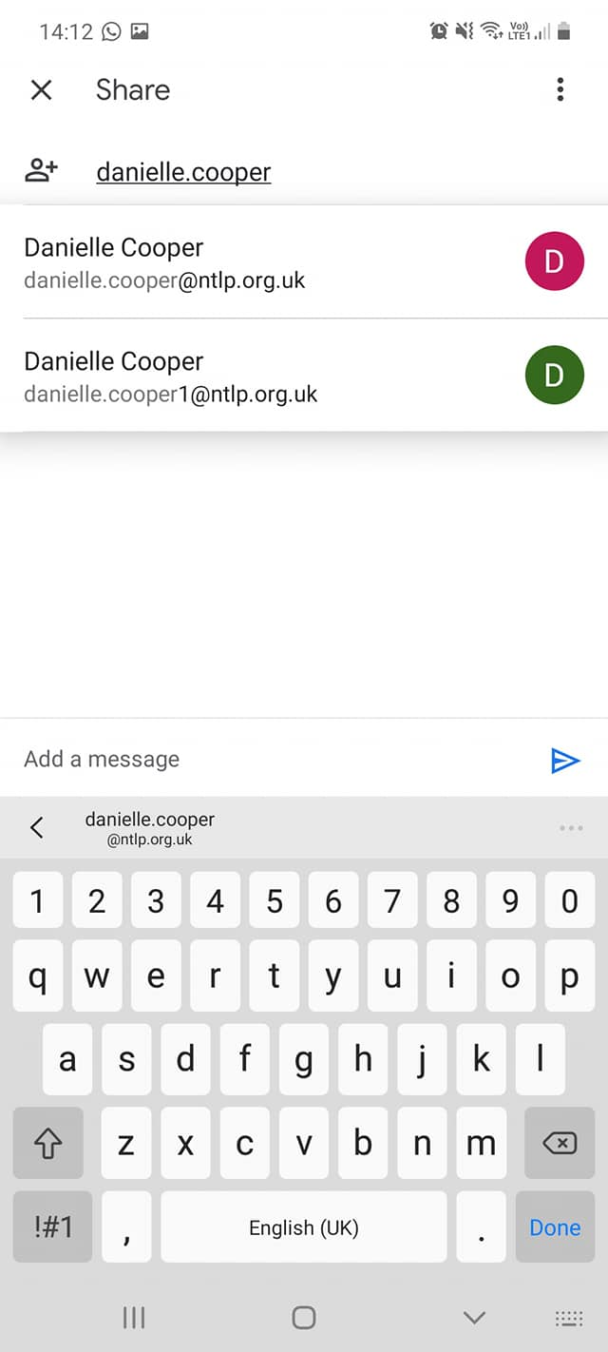

When you have selected your teacher(s), you can write a message to them using the ‘Add a message’ box. When you are ready to share your work, click on the triangle

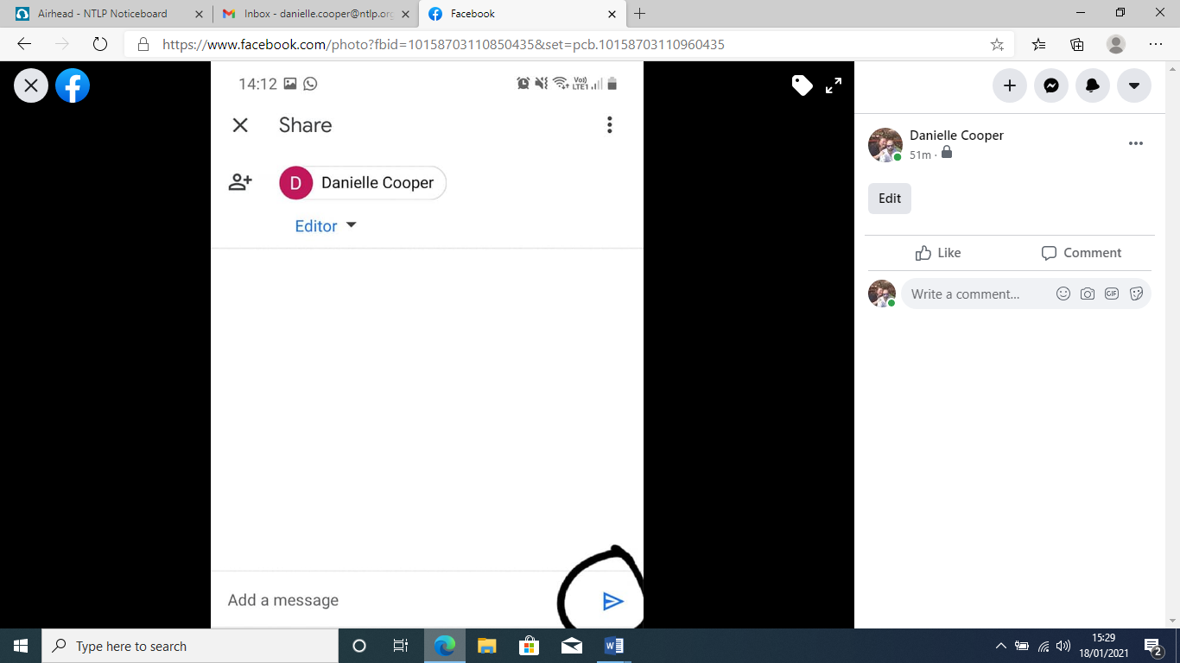

Your teacher(s) will receive an email alerting them that you have shared work with them

