**Uploading to Google Classroom from a Laptop/Computer**

In the ‘Classwork’ section click on ‘View Assignment’ for specific lesson

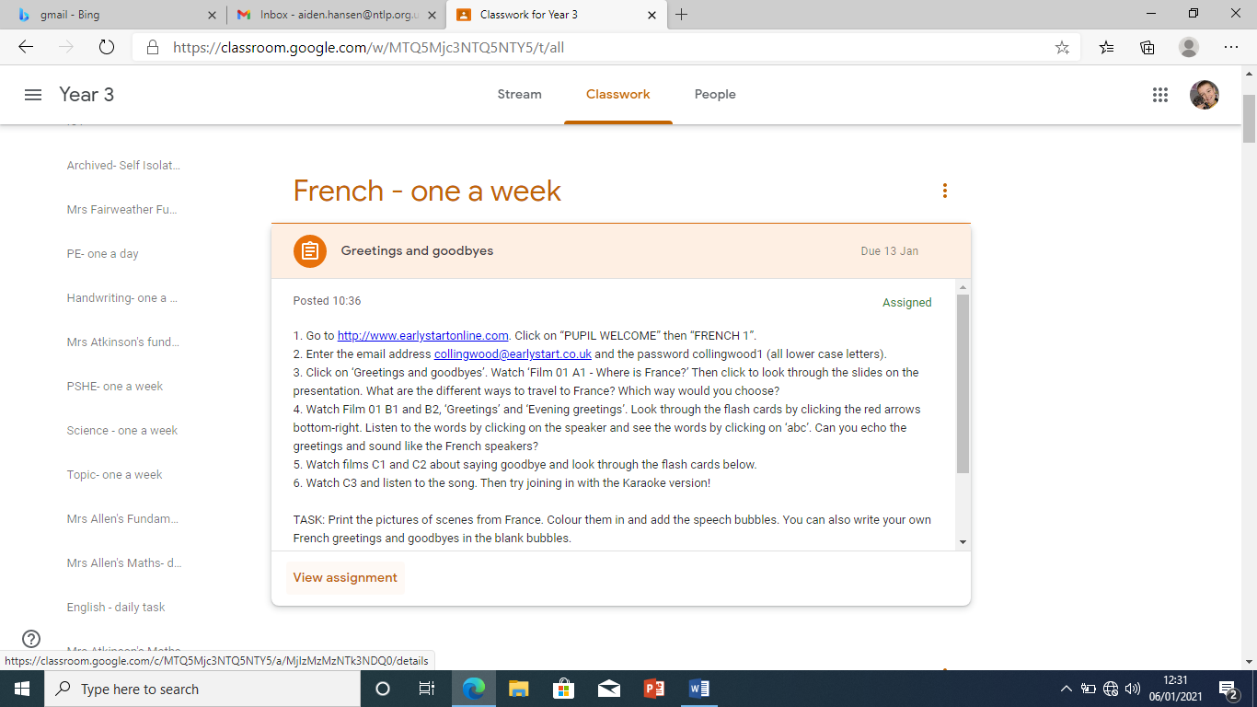

Go to Your Work in top right and click on ‘+ Add or create’

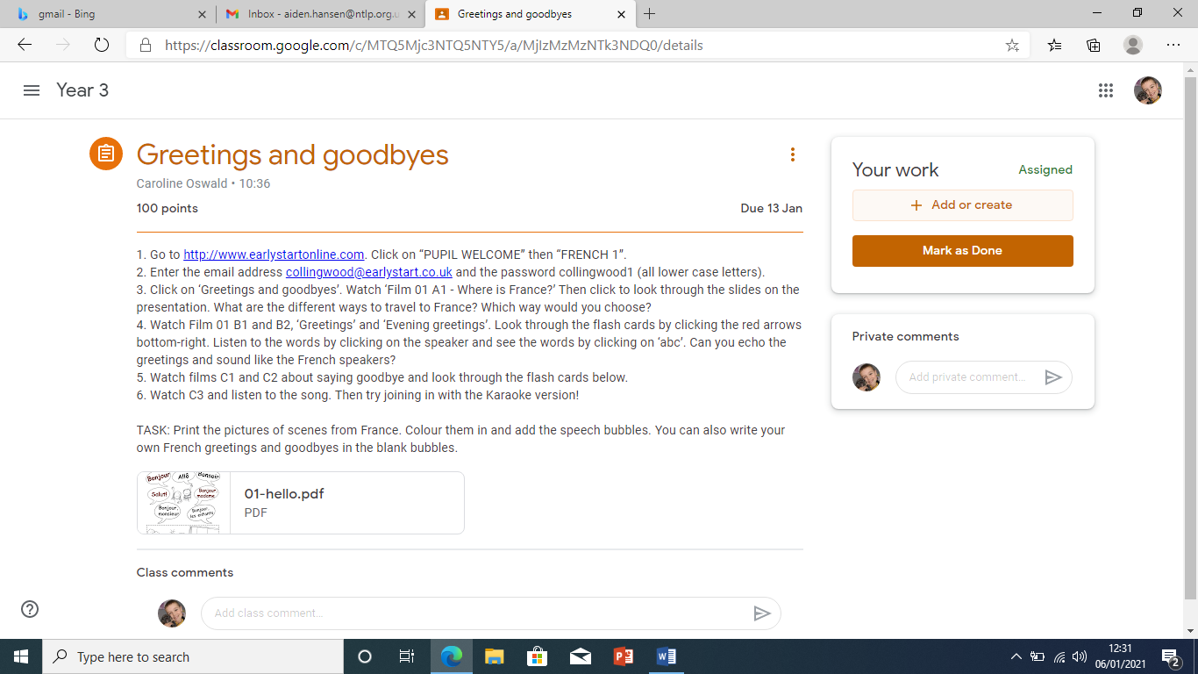

Click on ‘File’ in the drop screen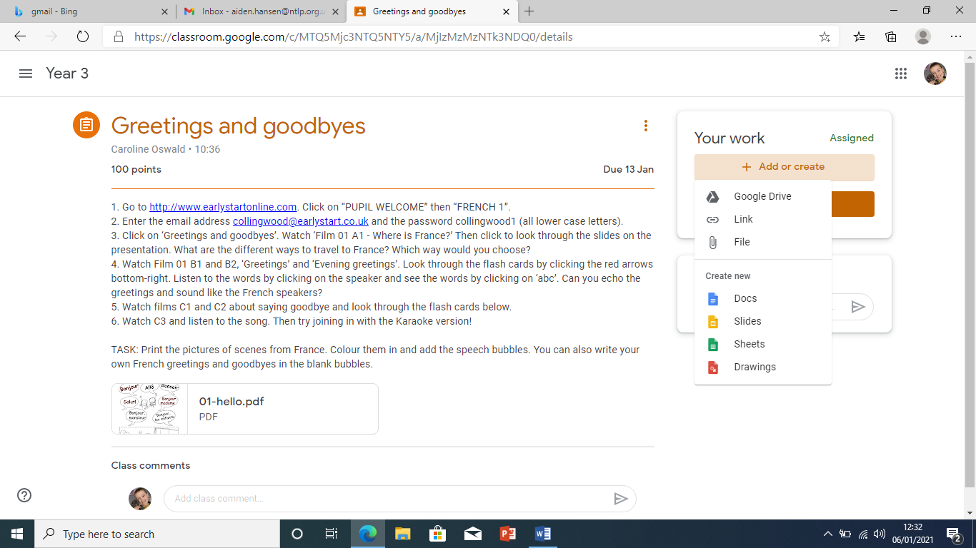

A screen will appear allowing you to upload work. Click on ‘Browse’

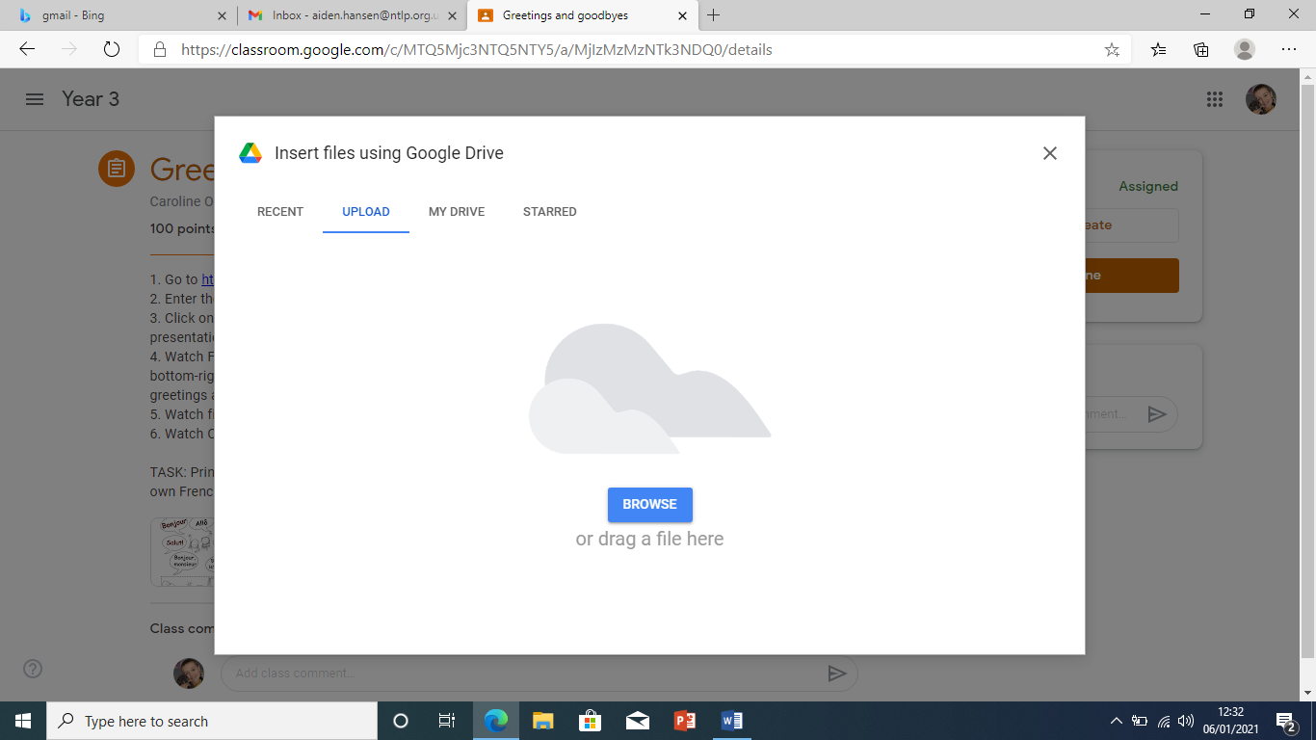

Find the document you want to upload, click on it and press open (or double click to automatically open)

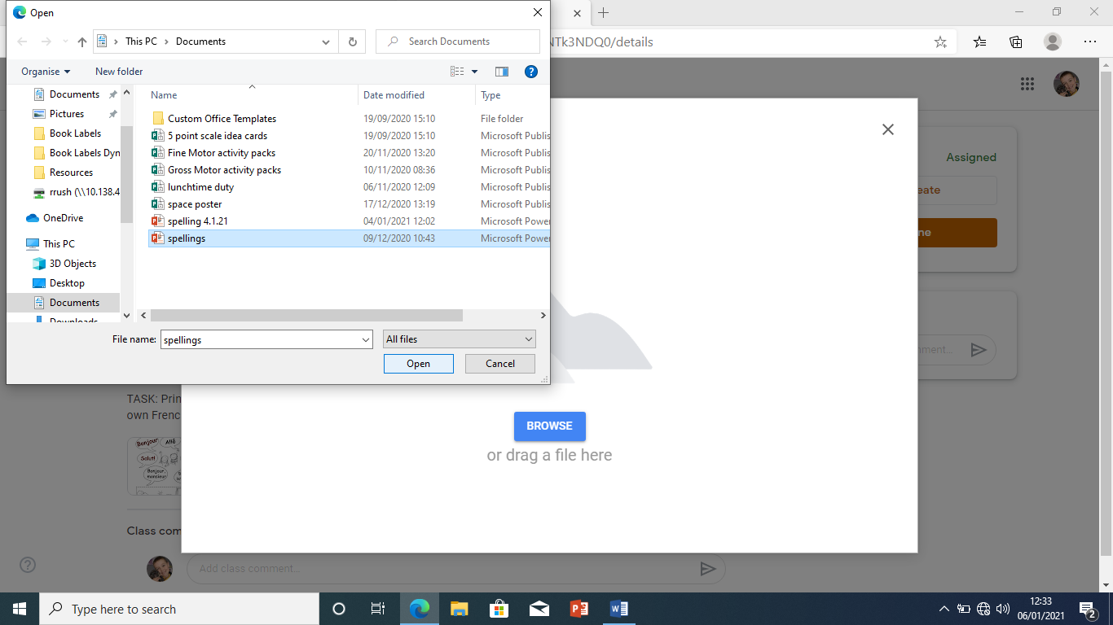

This screen will appear for a few seconds while it uploads

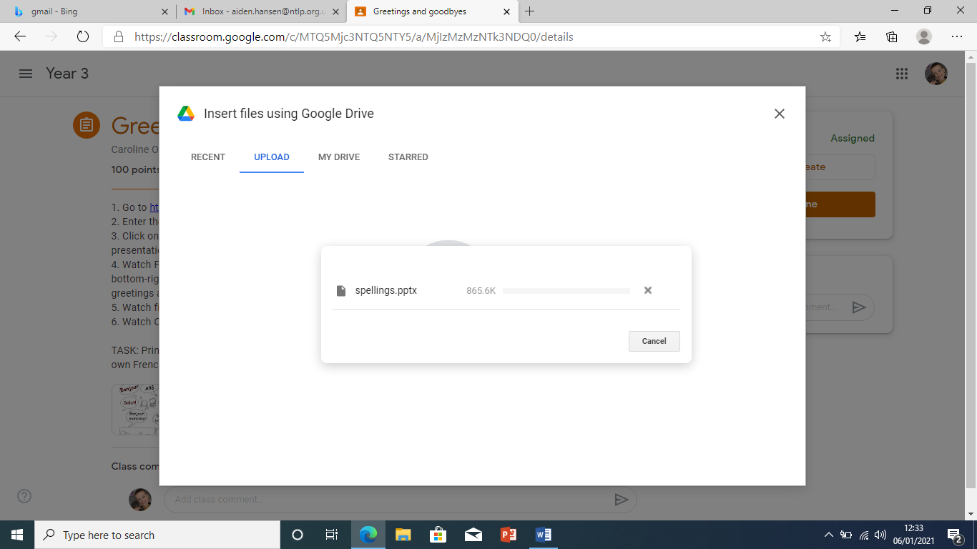

Upload will appear in ‘Your Work’ then click ‘Hand In’ – Job Done!

